Press information

Executive Vice President of Global Sales & Marketing drives international growth forward
Since September, Andreas Seum has been responsible for the global expansion of sales and marketing at TDM Systems
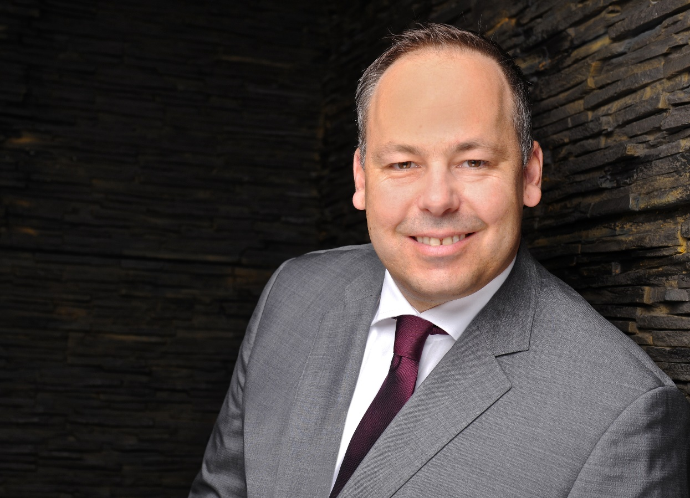
Andreas Seum, Executive Vice President Global sales & Marketing Image: TDM Systems

Tübingen, 10 November 2022 – In September, Andreas Seum was made the new Executive Vice President of Global Sales & Marketing at TDM Systems, the market leader for digital tool data management in the machining industry. By appointing Seum, TDM Systems sets out to further expand business operations, particularly in global target markets.

"In our core market of Germany, we are the market leaders. We stand for 100% tool management and are therefore right at the heart of the digital transformation," stresses Andreas Seum. After completing his diploma in communications engineering, specializing in digital communications, Seum learned about the technology from scratch. Having worked operationally in close contact with the customer at a network company, he later transitioned to the Sales and Consulting department so that he could also provide strategic advice to customers. He was able to utilize this blend of operational, technical, and strategic skills at companies such as Siemens, where he led the strategy department in the field of IT security and infrastructure and subsequently implemented the developed strategies globally with a dedicated business unit. His most recent position was at Hexagon Manufacturing Intelligence, where he was General Manager for the DACH region in the field of production software.
As the new Executive Vice President of Global Sales & Marketing, Seum sets out to "deepen the global footprint of TDM solutions." His growth strategy will focus on the target markets of North America, Asia and the already strong EMEA market. To gain further market shares here, TDM Systems will pay even greater attention to the customer's specific requirements and actively expand the customer base via direct and indirect channels.
Jean-Paul Seuren, Managing Director of TDM Systems, has every confidence: "With Andreas Seum on board as Executive Vice President of Global Sales & Marketing, we will hit our growth targets." Because Seum brings with him more than 26 years of experience not only in the software and machining industry but also in sales. Seuren knows that "Andreas Seum thinks in entirely strategic terms, always focused on the customer, and he knows the requirements of the global markets very well."

Print-quality images are available via the following link:
https://archiv.storyletter.de/download/TDMSystems_Andreas_Seum.jpg

Your contact person:

Daniela Steinhart

Telephone +49 (0) 7071 9492 760
daniela.steinhart@tdmsystems.com

TDM Systems GmbH
A member of the Sandvik Group
Derendinger Strasse 53
72072 Tübingen, Germany
http://tdmsystems.com/

Agency contact:

Mara Ebinger

Telephone +49 (0) 7071 9387 2159
m.ebinger@storymaker.de

Storymaker GmbH
Derendinger Strasse 50
72072 Tübingen, Germany
http://www.storymaker.de/

About TDM Systems
For over 30 years, TDM Systems GmbH, Tübingen has been the leading provider of tool management solutions in the area of machining. TDM Systems focuses specifically on process optimization through optimal tool planning and provisioning. Creating and editing tool data and graphics, integrating tool expertise and 3D graphics into the CAM engineering, and organizing the complete tool circulation at the shopfloor level are the three core competencies of TDM Systems. TDM Systems also offers a cloud-based entry-level solution for tool management especially for small companies with TDM Cloud Essentials. As a member of the Sandvik Group, TDM Systems draws on the expertise of various tool manufacturers when developing its software products.

www.tdmsystems.com

