Press release

Data is the new energy: How data takes any production to a new digital level
TDM Systems is presenting the potential of tool and machine data at EMO 2023 from September 18–23, 2023
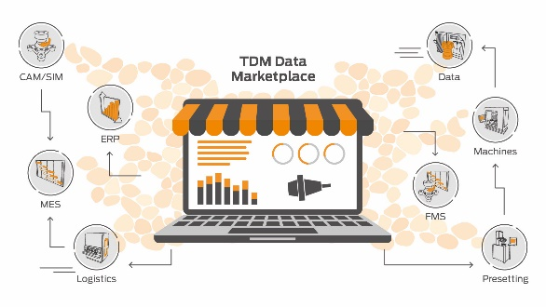
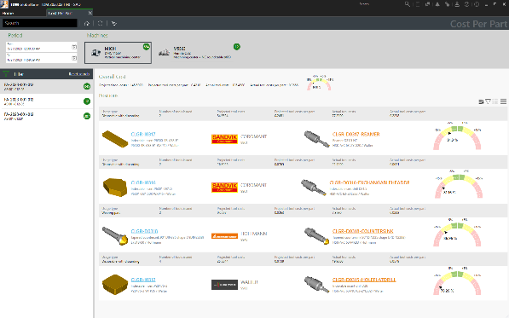

TDM Cost per Part enables a real calculation of tooling costs per workpiece and order. | The TDM data marketplace symbolizes the networking and integration of data and systems in a machining shopfloor.

Tübingen, Germany, June 29, 2023 – TDM Systems is presenting innovative solutions at EMO 2023 that enable machining companies to manage 100 percent of their tools and realize the full potential of their machine data. In addition to presenting its comprehensive tool management software, the leading software manufacturer for the management of tool data in the machining sector is also presenting the "Cost per Part" controlling tool.

Data is considered "the new energy" for production and business processes. However, to successfully create value with data, its quality is crucial. If this is not guaranteed, companies continually lose capital, according to Jean-Paul Seuren, Managing Director of TDM Systems. According to a study by Gartner, the average cost to an organization due to poor data quality is 15 percent to 25 percent of revenue per year. IBM also shares this assessment, and estimates the loss for companies in the U.S. due to poor data quality at $3.1 trillion. At the world's leading trade show for production technologies – EMO 2023 (Hall 009/Stand B23) in Hanover – TDM Systems will be presenting how a high-quality database can be built up for optimum value creation. Jean-Paul Seuren and Andreas Seum, Executive Vice President Global Sales & Marketing, will therefore present TDM Systems' new campaign "Data is the New Energy" to the trade show visitors and talk about data solutions and services as well as TDM's role as a data marketplace in a manufacturing company.
Optimized tool management
The experts from TDM Systems will demonstrate how 100 percent tool management with TDM solutions works. One major advantage is that, thanks to numerous interfaces to relevant planning and manufacturing systems, optimum networking and an automated data flow are realized. This enables safe manufacturing processes and absolute transparency. This pays off for the users: Machine downtimes are reduced by up to 30 percent and productivity increases. In addition, tooling costs are reduced. TDM users confirm savings of up to 30 percent and a halving of tool variety. Visitors to the booth will learn how to digitalize and optimize the entire tool management and tool circulation on the shopfloor.
New TDM Global Line Module: Calculate real tooling costs per workpiece and order now
Especially for productions with series production, it is advantageous to calculate and track the real development of tooling costs per workpiece and order. If the actual tooling costs are permanently higher than the planned costs, the entire calculation and the prices have to be adjusted. In addition, the controlling of the tool unit costs also enables an optimization of the production processes. For example, if tool breakages occur repeatedly at the same machining steps, companies can recognize them and react by using other tools or technologies. With the efficient "Cost per Part" controlling tool, TDM Systems is closing the gap between the planned cost calculations based on tool life and the real costs incurred based on stock movements. The TDM Systems experts will show trade show visitors how the software can be used ideally.

Closing the Loop: Increasing efficiency with partners
TDM Systems provides innovative solutions that take care of data management and the physical organization of tools all the way to the machine. However, knowledge or consideration of machine data is increasingly indispensable for optimized tool provision. TDM Systems therefore offers the experts at Comara GmbH (www.comara.de/en/) the opportunity to present their solutions for machine data acquisition and production optimization. The company, which, like TDM Systems, is also part of the Sandvik Group, specializes in solutions for machine connection and the evaluation of machine data. The Comara portfolio is the ideal complement to the TDM solutions for an end-to-end data and process chain – from planning right through to the machine.

TDM Systems also has a close cooperation with the machine manufacturer DMG MORI and will therefore also be present at the DMG MORI booth in Hall 2. There, trade show visitors can find out about the entire TDM product range, from entry-level solutions through to fully integrated expansion for global use around DMG MORI machines. As a special highlight, visitors can expect a new product launch, which TDM Systems will present together with DMG MORI for the first time at EMO.

For Jean-Paul Seuren, EMO 2023 is already a highlight: "We are looking forward to many interesting discussions and also to the launch of our new campaign "Data is the New Energy", and we are very excited to see how people will react."

Print-quality images are available via the following link:
http://archiv.storyletter.de/download/TDM_Systems_EMO2023_Images_EN.zip

Your contact:

Sandra Müller

Telephone +49 (0) 7071 9492 1173
sandra.mueller@tdmsystems.com

TDM Systems GmbH
A member of the Sandvik Group
Derendinger Strasse 53
72072 Tübingen, Germany
http://tdmsystems.com/

Agency contact:

Mara Ebinger

Telephone +49 (0) 7071 9387 2159
m.ebinger@storymaker.de

Storymaker GmbH
Derendinger Strasse 50
72072 Tübingen, Germany
http://www.storymaker.de/

About TDM Systems
For over 30 years, TDM Systems GmbH, Tübingen has been the leading provider of tool management solutions in the area of machining. TDM Systems focuses specifically on process optimization through optimal tool planning and provisioning. Creating and editing tool data and graphics, integrating tool expertise and 3D graphics into the CAM engineering, and organizing the complete tool circulation at the shopfloor level are the three core competencies of TDM Systems. TDM Systems also offers a cloud-based entry-level solution for tool management especially for small companies with TDM Cloud Essentials. As a member of the Sandvik Group, TDM Systems draws on the expertise of various tool manufacturers when developing its software products.

www.tdmsystems.com

