PRESS RELEASE

Focus on the user: TDM Systems presents a new software release

Practical innovations for TDM Global Line and TDM ClassiX

- Customer feedback as a driver of the 2024 release
- Simplified tool crib logistics with TDM ScanEasy
- TDM WebCatalog extended

Tübingen, December 12, 2023 – Good news for the customers of TDM Systems: With a comprehensive software release and the new TDM ScanEasy logistics application, the Tübingen-based company is making it even easier to get started with digital tool management. With the updates for TDM Global Line and TDM ClassiX, tool and order data can be managed much more efficiently and practically. 2024 release and TDM ScanEasy are available to users with immediate effect.

Customers in the machining industry are constantly facing new challenges. This is why Timo Kanz, Head of Product & Technology at TDM Systems, attaches great importance to maintaining close contact with users: "We want our solutions to help our customers master their challenges and processes. That is why we are guided by their daily practice. And that is why we deliberately incorporate specific suggestions for improvement from users into our software releases."

New functions make handling easier
Optimally prepared, high-quality data is the basic prerequisite for every application. The further development of the tools for data management and generation is therefore a focus of the new release. TDM ClassiX users now have at their disposal predefined tool assembly templates for various tool types. More than four workpiece-side insertion points are now supported in both systems. TDM Global Line also features improved visualization in 3D tool assembly, since the data transfer is integrated into the dialog function. This makes it even easier for users to assemble tools error-free on the computer. A new status management function for orders and work steps in TDM Global Line also makes it easier to process production orders.

TDM ScanEasy optimizes tool crib logistics
Efficient tool crib logistics not only helps to optimize work processes, it also opens up the opportunity to reduce tooling costs. TDM Global Line and TDM ClassiX now offer new features that further improve tool crib logistics. TDM ScanEasy, the new mobile barcode scanner solution, significantly simplifies work in the production environment. The lean, browser-based solution supports the real-time booking of scanned data via Wi-Fi. With the extension of the TDMstoreasy cabinet software, tool assemblies, gauge and calibration equipment and fixtures can be booked here. Direct access to the data in the TDM WebCatalog, which is now possible, ensures optimized data management.

TDM WebCatalog: 345,000 tool data records integrated
New manufacturers, new data – the updated TDM WebCatalog, the digital tool catalog from TDM Systems, offers more than 345,000 tool data records from eleven manufacturers in the cloud with the new release. New additions are data from Sartorius tools and OSG. The TDM WebCatalog is updated regularly and will incorporate additional manufacturers in 2024.

Press photos
Image 1
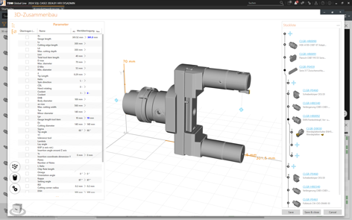
Image caption: The 3D tool assembly in TDM Global Line now has improved visualization.
Image source: TDM Systems GmbH

Image 2
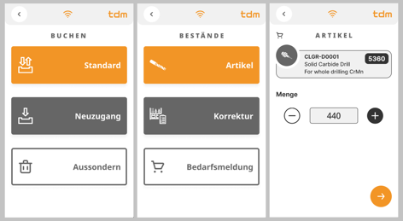
Image caption: TDM ScanEasy significantly simplifies work in the production environment with real-time booking of scanned data via Wi-Fi.
Image source: TDM Systems GmbH

Image 3
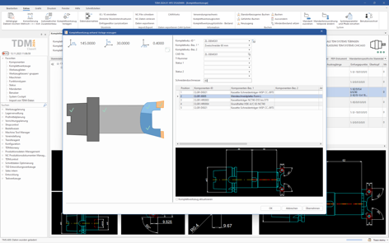
Image caption: Predefined tool assembly templates for various tool types are now available for TDM ClassiX users.
Image source: TDM Systems GmbH

You can find printable images here.

About TDM Systems
For 30 years, TDM Systems GmbH has been the leading provider of tool management solutions in the area of machining. The Tübingen-based company focuses on process optimization through digital tool planning and provision. The core competencies of TDM Systems are the generation of tool data and graphics, integration into CAM planning and tool organization at shopfloor level. TDM Cloud Essentials enables small companies to get started with cloud-based tool management. With the TDM iCut and TDM appCom solutions, TDM Systems now also offers digital assistants for optimizing machine runtimes. TDM Systems is part of the Sandvik Group.

Press contact:
thepublic GmbH
Jonathan Wurster
PR Consultant
Telephone: +49 (0) 151 146480 48
E-mail: j.wurster@thepublicpr.com

Company contact:
TDM Systems GmbH
Sandra Müller
Marketing Communication Manager
Telephone +49 (0) 170 6730072
sandra.mueller@tdmsystems.com

