Press release

TDM Systems Presents Tool Lifecycle Management 4.0

TDM Systems will show off its completely new TLM concept for digital production at EMO 2017
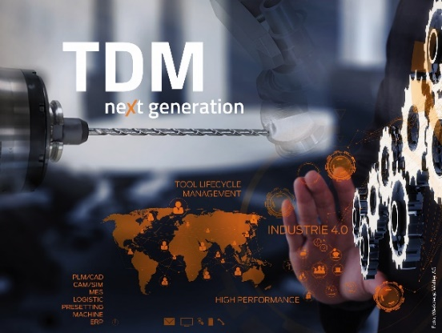
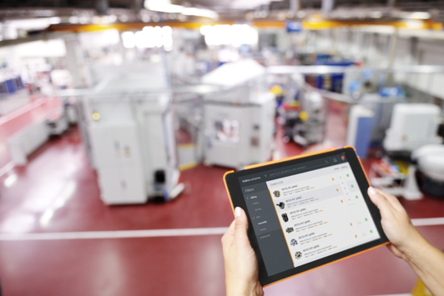
Caption: The 3D tool assembling in TDM 2017 GL – Thanks to the intuitive user interface, tools can be configured with just a few clicks.
Image TDM Systems
Caption: TDM next generation is the Industrie 4.0 solution for Tool Data Management in the machining industry. Image: TDM Systems

Tübingen – August 16, 2017 – More than 25 years ago, TDM Systems revolutionized the metal cutting industry with the world's first digital solution for Tool Data Management – a pioneering achievement that was already thinking about the requirements of today's fourth industrial revolution even then. Earlier this year, the tool data specialist presented a completely modernized software system with "TDM next generation". Now the company is repositioning Tool Lifecycle Management for digital production – to be seen from September 18 - 23, 2017 at the EMO in Hannover.
"Our goal is to navigate the machining industry safely through digital pro-duction," says Peter Schneck, Managing Director of TDM Systems. "Therefore, continuous data flow is indispensable. This is the only way to bring together all of the necessary data, the right tool, and the optimal process at the right time." For that reason, TDM Systems is not only developing Tool Lifecycle Management (TLM) but is putting it on a completely new basis. "We are using a single source of truth approach to ensure transparency from the planning of a product through its delivery." As to what this means exactly will be presented by TDM Systems for the first time at EMO 2017.
TDM Goes Global
TDM Systems' entire trade show presence is characterized by digitization and Industrie 4.0. The tool data specialist from Tübingen offers entry-level options for digitization beginners as well as complex global TLM solutions for international companies with TDM 2017 and TDM 2017 Global Line under the umbrella of "TDM next generation".
As part of a detailed presentation, booth visitors will learn more about the new 3D tool assembly in TDM 2017 Global Line, the "Machine Process Control" (MPC) module, as well as crib management with the TDM Global Line 2017 add on TDM Flex Crib, which enables mobile crib management to book and query tools.
TDM Systems is Exhibiting at EMO 2017 with the Following Partners:
• DMG MORI, Hall 2, Booth A21
• Walter, Hall 3, Booth B34
• KELCH, Hall 4, Booth C26
• SANDVIK Coromant, Hall 5, Booth B18
• GROB-WERKE, Hall 12, Booth B04
TDM Systems will present its completely new TLM solution for digital production at the press conference with SANDVIK on September 19, 2017 at 4 pm in the Convention Center of the Hannover Trade Show (Hall 13/14).

Print-quality graphics are available at:
http://archiv.storyletter.de/download/TDM_PI_EMO_2017_Images.zip

Agency Contact:

Judith Klingler

Phone +49.7071.93872-13
j.klingler@storymaker.de

Storymaker GmbH
Derendinger Strasse 50
72072 Tübingen, Germany
http://www.storymaker.de/
Contact:

Sandra Schneck

Phone +49.7071.9492-1173
sandra.schneck@tdmsystems.com

TDM Systems GmbH
A Member of the Sandvik Group
Derendinger Strasse 53
72072 Tübingen, Germany
http://www.tdmsystems.com/
twitter: https://twitter.com/TDM_Systems

About TDM Systems

Tübingen-based TDM Systems GmbH has been the leading provider in Tool Data Management for the metal cutting industry for over 25 years. With the Tool Lifecycle Management strategy, TDM Systems is focusing specifically on process optimization through optimal tool planning and provisioning. Creating and editing tool data and graphics, integrating tool expertise and 3D graphics into the CAM engineering, as well as organizing the complete tool cycle at the shop floor level are the three core competencies of TDM Systems and are the pillars of the TLM strategy. As a center of excellence within the Sandvik Group, TDM Systems draws on the experience of various tool manufacturers when developing its software products.

www.tdmsystems.com

