Press release

Award-winning: TDM next generation
TDM Systems receives the “Innovationspreis-IT 2017” (Innovation Award in IT 2017) for innovative software solutions

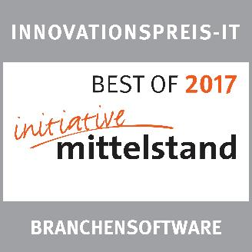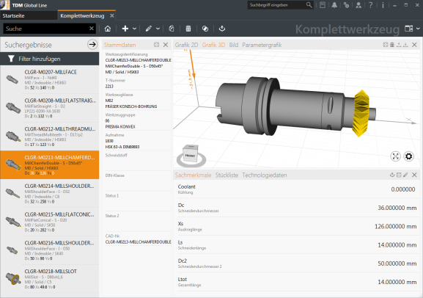
CAPTION: "TDM next generation" proves its value as an innovative solutions.
Image: TDM Systems

CAPTION: The award in the form of the BEST OF certificate. Image: TDM Systems

Tübingen, Germany 20. April 2017 – The software provider TDM Systems from Tübingen won over the judges of the renowned INNOVATIONSPREIS-IT with their "TDM next generation" solution. Receiving this award makes TDM Systems one of the top providers of the year. Since 2004, “Initiative Mittelstand” (a consulting group for small and medium sized businesses) has been selecting and awarding the best and most innovative IT products and solutions that make SMEs fit for a successful digital future.
TDM Systems offers solutions for companies in the metal cutting industry that are used to optimize the tool flow and, as a result, the entire production process. The Tool Lifecycle Management (TLM) approach is thus becoming the pivot point and keystone in the production sector, towards successfully meeting the requirements of Industrie 4.0. “Initiative Mittelstand” has rewarded these services with the “Innovationspreis-IT 2017”.
With their award-winning solution "TDM next generation", TDM Systems has modernized their existing software for the Tool Lifecycle Management to help facilitate the entry of small and medium sized enterprises into digital TDM Tool Management or to help simplify the continuation of Industrie 4.0 efforts.
This further development of the tried and tested TDM solution enables innovative, globally-applicable and extremely high-performance TDM Tool Management, which can additionally be scaled to the requirements and size of the company. Thus, the TDM software builds the link between the virtual world of planning and the real world of production, and helps users to achieve a smooth production process.
"TDM next generation fulfills all of the criteria that are crucial in selecting the winner of the “Innovationspreis-IT”", emphasizes Peter Schneck, Managing Director of TDM Systems: "Innovative content, use and mid-sized sector suitability."
An independent panel of expert judges, consisting of top-class professors, IT industry experts, scientists and journalist, assessed all product and solution submissions to ensure maximum objectivity.
In a further step, users, as well as their customers, partners, employees or other interested parties can vote for their favorite software solution 2017 from the “Best of IT” list. Voting is possible here.
Print-quality graphics are available at:
http://archiv.storyletter.de/download/TDM_PI_Innovationspreis2017_Images.zip
Agency contact:

Judith Klingler

Telephone +49.7071.93872-13
j.klingler@storymaker.de

Storymaker GmbH
Derendinger Strasse 50
72072 Tübingen, Germany
http://www.storymaker.de/
Your contact person:

Sandra Schneck

Telephone +49.7071.9492-1173
sandra.schneck@tdmsystems.com

TDM Systems GmbH
A Member of the Sandvik Group
Derendinger Strasse 53
72072 Tübingen, Germany
http://www.tdmsystems.com/
Twitter: https://twitter.com/TDM_Systems

About TDM Systems

Tübingen-based TDM Systems GmbH has been the leading provider in Tool Data Management for the metal cutting industry for over 25 years. With its Tool Lifecycle Management strategy, TDM Systems focuses primarily on process optimization by planning and supplying tools in the most efficient way possible. Creating and editing tool data and graphics, integrating tool expertise and 3D graphics into CAM planning processes and organizing the entire tool cycle at the shop floor level are the three core areas of expertise of TDM Systems and the pillars of the TLM strategy. As a center of expertise within the Sandvik Group, TDM Systems draws on the experience of various tool manufacturers when developing its software products.

www.tdmsystems.com

