TDM User Day takes a look into the future of Tool Lifecycle Management

More than 110 participants have experienced Tool Data Management as the nucleus for Industrie 4.0 at the new Walter AG Technology Center

Tübingen, January 11, 2017 – For TDM Systems GmbH, the year 2017 will be one of numerous innovations. These innovations have been presented at the TDM User Day end of November 2016. The software specialist for Tool Data Management, based in Tübingen, Germany, calls these innovations the "TDM next generation" of Tool Lifecycle Management. This next generation enables both an easy entry into the TDM world and highly integrated, global system integrations.

"Here you can find people who have both the ability and the desire to drive the digital transformation revolution as we are experiencing it right now!" exclaimed Mirko Merlo, Chairman of the Board of Walter AG, as he welcomed more than 110 participants to the TDM User Day 2016 at the "Technology Center" in Tübingen, which had only opened a few weeks prior. The digital transformation will ultimately lead us to Industrie 4.0. Merlo is confident that this revolution will offer added value for all persons involved. "As always, time is critical." The development curve will soon be rising steeply, and Merlo believes that now is the right point in time to begin with digitalization.
Cost reduction, digitalization and increasing IT requirements are three of the ten most important challenges for the manufacturing industry, according to a study entitled "Business Performance Index 2016" that was carried out by Techconsult GmbH. Peter Schneck, Managing Director of TDM Systems, stated that TDM is using the Tool Lifecycle Management strategy to support its customers precisely in these areas: "A successful Tool Lifecycle Management project always reduces tool circulation costs and increases machine running times." TDM Systems supports the introduction of Indutrie 4.0 with a comprehensive offer scope around the tool. In addition, TDM next generation offers a platform that fulfills global as well as local requirements in every conceivable environment.
Just three years ago, the terms 'Industrie 4.0' and 'digitalization' were unknown to many small and medium-sized enterprises, according to the Techconsult study. This has changed drastically, at least among User Days participants, who were constantly talking about the "Industrial Internet of Things" like never before. The topic of Industrie 4.0 is now a subject with relevance to the shop floor.
Sales Director Eugen Bollinger intends to accompany customers on their way to Industrie 4.0. Therefore, he emphasized the investment protection that TDM users enjoy: "TDM next generation will be a state-of-the-art, advanced application, where both current TDM modules and TDM Global Line modules can be used in parallel." Product Manager Stefan Schmid pointed out that companies using TDM next generation can take the first steps in the direction of Industrie 4.0 without complete renewal and system change. It is also possible for newcomers to get set up with TLM successfully while keeping initial expenditures low.
Roland Larch, Head of Mechatronics at ECI-Manufacturing GmbH, and Volker Schwegler, Senior Consultant and Product Manager at TDM Systems, show specifically what Industrie 4.0 might look like within the tool environment. They introduced the new TDM Global Line "MPC (Machine Process Control)" module in combination with the "ECI-Connect" middleware, a hardware and software product which integrates the Machine Control System to TDM. The data exchange between ECI connect and TDM MPC is based on a control-independent web service that both companies developed together. "Instead of theoretical planning data, TDM uses the real tool data from the machine tool in real time", says Schwegler. For TDM, ECI connect enables the MCC (Machine Control Connect) between the TDM applications and a wide range of CNC control systems. This solution is based on an industrial PC and reads all data relating to the tool from the Machine Control System. TDM uses it for further evaluation in the MPC (Machine Process Control). In clear diagrams and tables, the TDM MPC displays the current state of the tools in the machine park and in the magazines of the individual machines. This allows for an early provision of replacement tools, so that tool setup time is practically no longer required. Furthermore, this makes bi-directional data transfer possible between TDM and the machine. Tool offset data can be transmitted directly into CNC magazine management. In doing so, the access method specified by the control system manufacturer is taken into account for the connection of different machines.
Another innovation is the "Internet of Tools" platform, which is online since 12/15/2016 (www.internet-of-tools.com). It was conceived as a "global home of digital cutting tools". The first application is the "Tool Designer", which TDM Systems Project Manager Christian Kübel presented, using a solid carbide tool as an example: "The Tool Designer is used to generate a 3D tool assembly graphic in a very simple and intuitive way." Further applications should be available in 2017, initially for rotationally symmetric tools and eventually for turning and grooving tools as well.

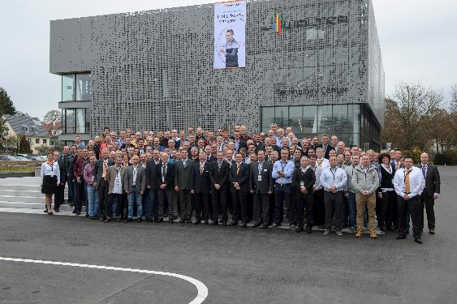
Caption: In November 2016 more than 110 members of the TDM User Group met for the annual User Day.
Image: TDM Systems

Print-quality images are available at: http://archiv.storyletter.de/download/TDM_User_Day_2016.zip

About TDM Systems
Tübingen-based TDM Systems GmbH has been the leading provider in Tool Data Management for the metal cutting industry for over 25 years. With its Tool Lifecycle Management strategy, TDM Systems focuses primarily on process optimization by planning and supplying tools in the most efficient way possible. Creating and editing tool data and graphics, integrating tool expertise and 3D graphics into CAM planning processes and organizing the entire tool cycle at the shop floor level are the three core areas of expertise of TDM Systems and the pillars of the TLM strategy. As a center of expertise within the Sandvik Group, TDM Systems draws on the experience of various tool manufacturers when developing its software products.

www.tdmsystems.com

