International and fit for the future

TDM Systems is making a name for itself and its Tool Lifecycle Management solutions on the European market

Tübingen, Germany, 05. January 2016 – TDM Systems GmbH, the leading software provider for managing tool data in the area of metal cutting, is showcasing its solutions for Tool Lifecycle Management at three international trade shows in spring.

TDM Systems is focusing on internationalization and Tool Data Management of the future in 2016. The Tübingen-based software company is linking the two topics at its trade show appearances in Düsseldorf, Parma and Paris: TDM Systems presenting itself as the IT expert for the metal cutting industry and is showcasing the scope of delivery for its Tool Lifecycle Management (TLM) at METAV in Düsseldorf, Germany from February 23-27, at MECSPE in Parma, Italy from March 17-19 and at the Industrie in Paris, France from April 4-8, 2016.

TDM Systems is an important partner for manufacturing companies for tackling Industry 4.0 projects where implementation is essential to guaranteeing successful, future-oriented development. The TLM solutions from TDM Systems ensure consistent communication and exchange of tool and production data across all participating systems—all with a central platform.

TDM Systems as a company is not the only one embracing the concept of internationalization. Tool Data Management has to work around the globe as well. TDM Global Line was launched in August of last year. It allows manufacturers high-speed access to company-internal tool data at any time and across all locations. The software, which TDM Systems is presenting at the trade shows, is an important component for current customers seeking to integrate more locations into their TDM application.
TDM Systems is also showcasing “TDM Global Line Flex Crib”, a browser-controlled add-on for TDM Global Line. It makes it possible to visualize tool items and tool assemblies (master data and 2D/3D graphics), carry out issuing dialogs (including with a scan function) and display issuing lists. A dashboard with management reports from crib logistics provides customers with a transparent overview of tool inventory and circulation at any time.

"Just like us, many of our customers are operating on an international scale. TDM Global Line lets us offer them a high-performance solution that works around the globe," says Peter Schneck, Managing Director of TDM Systems. "The web-based add-on for tablets accommodates modern user preferences, and makes work and communication simple, mobile and connected."

Image 1:
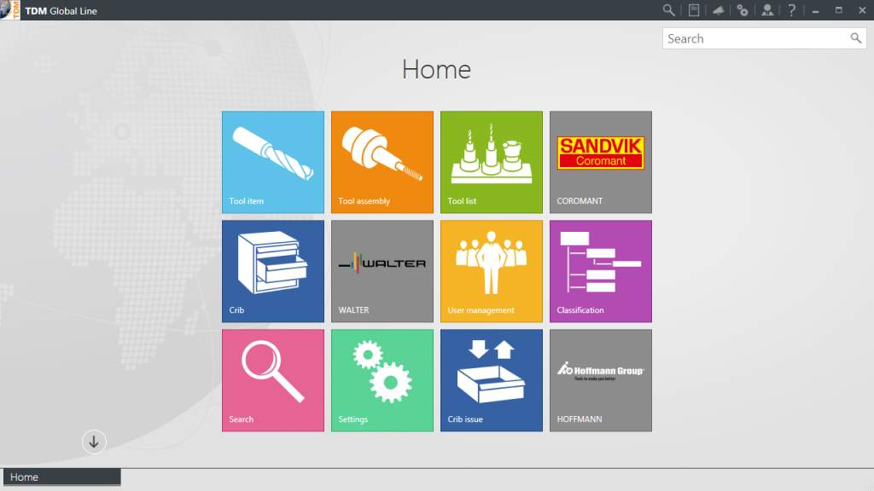
Caption: Alongside performance and architecture, TDM Global Line convinces with its fresh new software design.
Image: TDM Systems

Image 2:
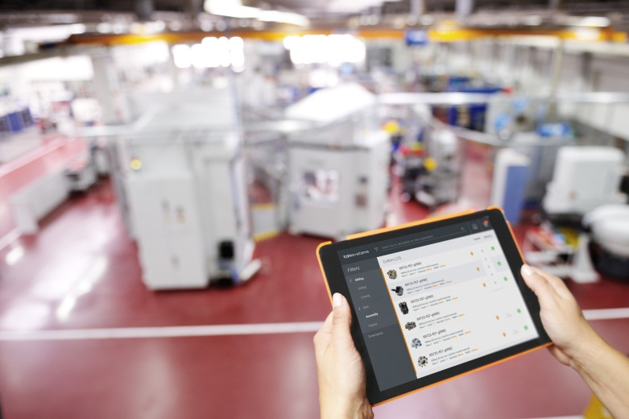
Caption: TDM Global Line Flex Crib – making tool crib management simple, mobile and connected.
Image: TDM Systems

Print-quality images are available at:
http://archiv.storyletter.de/download/TDM_EMO_2015_Bilder.zip

About TDM Systems
The Tübingen-based TDM Systems GmbH has been the leading provider for Tool Data Management for the metal cutting industry for over 25 years. With its Tool Lifecycle Management strategy, TDM Systems focuses primarily on process optimization by planning and supplying tools in the most efficient way possible. Creating and editing tool data and graphics, integrating tool expertise and 3D graphics into CAM planning processes and organizing the entire tool cycle at the shop floor level are the three core areas of expertise of TDM Systems and the pillars of the TLM strategy. As a center of expertise within the Sandvik Group,
TDM Systems draws on the experience of various tool manufacturers when developing its software products.

www.tdmsystems.com

