Tool Data Management of the future

TDM Systems presents its new generation of software for Tool Lifecycle Management on the international stage

Tübingen, 8th March 2017 – This spring, digital Tool Data Management specialist TDM Systems GmbH will present the next development stage of their Tool Lifecycle Management approach at three international trade shows in Italy, China and France. By releasing its new "TDM next generation" software, the software company from Tübingen, Germany offers new introductory options as well as highly integrated global systems integrations.

This year, TDM Systems is focusing on its new software generation "TDM next generation." "TDM next generation" is a state-of-the-art, highly evolved platform that can be used to operate all existing TDM modules and TDM Global Line modules simultaneously. TDM next generation features enhanced performance, worldwide networking and easy scalability, helping users implement their Industrie 4.0 requirements. As an IT expert for the metal cutting industry, TDM Systems will present the modern solution at the following upcoming trade shows: at MECSPE in Parma, Italy from March 23 - 25, 2017, at Industrie in Lyon, France, from April 4 - 7, 2017 and at CIMT in Beijing, China, from April 17 - 22, 2017.
By offering TDM next generation, TDM Systems is making its contribution to the ever-increasing digitalization of production and enabling its customers to completely renew and modernize their TDM solutions - without complex system change. The conversion from the previous 2-tier architecture the modern 3-tier architecture increases both performance and process reliability while simultaneously reducing installation and service effort. Additional advantages will include simplified interface handling, easy use of on-demand and browser-based solutions and the combined use of standard and engineering solutions. Our customers will find a solution tailored to their individual needs.

Overview of upcoming trade show appearances
- MECSPE 2017, March 23 - 25, 2017 in Parma, Italy: Building 2, Booth G04
- Industrie Lyon 2017, April 4 - 7, 2017 in Lyon, France: Building 6, Booth V112
- CIMT 2017, April 17 - 22, 2017 in Beijing, China: Building E10, Booth 103 at the Germany Pavillon.

Images:

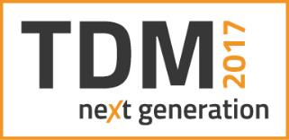
Caption: TDM next generation Logo
Image: TDM Systems

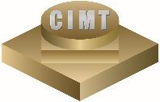

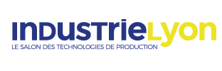
Caption: Logos of MECSPE, CIMT und Industrie 2017.
Images: TDM Systems

Print-quality images are available at:
http://archiv.storyletter.de/download/TDM_trade_fairs_images.zip
About TDM Systems
Tübingen-based TDM Systems GmbH has been the leading provider in Tool Data Management for the metal cutting industry for over 25 years. With the Tool Lifecycle Management strategy, TDM Systems is focusing specifically on process optimization through optimal tool planning and provisioning. Creating and editing tool data and graphics, integrating tool expertise and 3D graphics into the CAM engineering and organizing the complete tool cycle at the shop floor level are the three core competencies of TDM Systems and the pillars of the TLM strategy. As a center of expertise within the Sandvik Group, TDM Systems draws on the experience of various tool manufacturers when developing its software products.

www.tdmsystems.com

