New TDM Systems website is the hot spot for Tool Lifecycle Management

New design for the website of the Tübingen-based TLM specialist

Tübingen, June 01, 2016 – The Tübingen-based software company TDM Systems GmbH revised its website from scratch. The new site is online.

TDM Systems' Twitter followers are already aware: the homepage of the new website has slowly been revealed piece by piece over the last two weeks. Today, the website of the Tübingen-based company and leading provider of TLM solutions goes online.

What's new?
The TDM Arena is the centerpiece of the new site: It's the digital hot spot for news, interviews, user opinions and expert information related to TDM/TLM. In this section of the site, visitors can discover more about new TLM developments and trends.

In general, the redesign of the site follows a comprehensive concept that goes beyond providing current information about the company and TLM topics. In an effort to realign the corporate communication of TDM Systems, the new website serves as a communication center in which all information is collected. Visitors can access all important communications channels (YouTube, Twitter, LinkedIn, etc.) of the company from this central point.

"We didn't just redesign the appearance of our website. We completely overhauled the site as part of our new communication strategy," says Daniela Steinhart, Manager Marketing & PR at TDM Systems. "We want to inform visitors about the basic facets of TDM/TLM and present TDM Systems as an expert partner as well."
For this reason, the company has set great value on the new, clearly organized page structure and new, expanded content. TDM Systems offers an extensive range of tool management solutions that should be presented with the right amount of clearly structured content and the new "Tool Lifecycle Management" IT strategy. The new visual language, an attractive design and clearly structured content is guaranteed to assure future visitors that they have all the information they need.

Image:
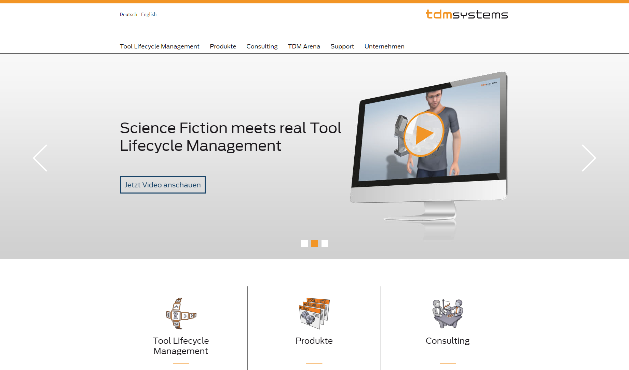
Image caption: The completely overhauled website features a new visual language and intuitive user guidance.

Print-quality images are available at:
http://archiv.storyletter.de/download/Bild_Website_Startseite.zip

About TDM Systems
The Tübingen-based TDM Systems GmbH has been the leading provider for Tool Data Management for the metal cutting industry for over 25 years. With the Tool Lifecycle Management strategy, TDM Systems is focusing specifically on process optimization through optimal tool planning and provisioning. Creating and editing tool data and graphics, integrating tool expertise and 3D graphics into the CAM engineering and organizing the complete tool cycle at the shop floor level are the three core competencies of TDM Systems and the pillars of the TLM strategy. As a center of expertise within the Sandvik Group, TDM Systems draws on the experience of various tool manufacturers when developing its software products.

www.tdmsystems.com

