TDM next generation makes tools fit for Industrie 4.0
TDM Systems sets the course for the Tool Management of the future

Tübingen – March 2, 2017 – With "TDM next generation", the Tübingen, Germany-based software specialist for Tool Data Management specialists at TDM Systems GmbH will ring in the age of Industrie 4.0 for tools – without throwing existing expertise overboard. For many existing customers, TDM modules are embedded deeply into the workflow and as such should remain viable well in the long term. Towards a connected world, TDM 2017 and TDM 2017 Global Line are now replacing version 4.8. All software modules are based on the same kernel and can be used in parallel.

"For TDM next generation, we have completely redesigned the software base and made it fit for all future requirements," explains Vice President Sales Eugen Bollinger. "It combines both of the software lines TDM 2017 and TDM 2017 Global Line, which are built on a common basis, but which work with different software architectures." The Tübingen team is particularly proud that they have succeeded in protecting the existing applications that customers are using. "We give our customers a clear positive outlook for the future while also ensuring absolute investment protection for the system." They can be further developed and at the same time implemented into future Industrie 4.0 applications, "completely in line with our overall IT strategy, “Tool Lifecycle Management".
Into the future without system discontinuity
Achim Müller is TDM's Vice President Technology. The mechanical engineer and computer scientist is only too aware of the current demands which are set in regards to Industrie 4.0. "TDM/TLM must be able to be applied, scaled, and extremely performant around the world." With TDM Global Line it does not matter anymore if the user is sitting in the main plant fifteen feet away from the server or on the other side of the globe – the response times are practically the same.
The difference: TDM 2017 provides classic 2-tier architecture for direct communication between server and database. TDM 2017 Global Line uses a 3-tier architecture with interconnected ISS application servers from Microsoft. They carry out all computations, ensuring that the transfer of data is substantially more efficient. The application servers are freely scalable and can handle virtually any number of users worldwide. Downloading tool data from catalogs or from the TDM Data and Graphic Generator is also substantially faster and easier.
All new and yet no break in development. How can that be? Project Manager Stefan Schmid has the answer. "We have separated the application data from the application itself, which makes further development of the system possible without having to change systems while doing so." This also improves data quality, security, service and the implementation of updates, which only have to be imported centrally on the application server. In addition, TDM 2017 simplifies the handling of interfaces and the use of on-demand and browser-based solutions, which can be combined with on-site solutions.
Spring cleaning for tool data
A substantial innovation is the referential integrity of the database. It sounds complicated, but it is actually quite simple, as Stefan Schmid explains. "We've relocated the knowledge about data dependencies from the application into the database because the database specializes in checking dependencies instantly and perfectly manages changes or deletions."
Further highlights in 2017 include the new 3D tool assembler in TDM 2017 Global Line and the tool search, which is similar to a simple Internet search. The new TDM-check examines data and the data structure of the TDM application and displays areas of potential improvement. A new import module gets tool data from standard sources. For data import, customer-specific templates can be defined and existing data records expanded.
The TDM Global Line 2017 add-on TDM FlexCrib for mobile tool crib management for booking and querying tools can be considered as being exemplary of Industrie 4.0. The licensing model for the new TDM 2017 Global Line is very attractive. Eugen Bollinger: "For installations with multiple plants and global applications, we are offering floating licenses as a lucrative entry-level product."
Images:

Image 1:
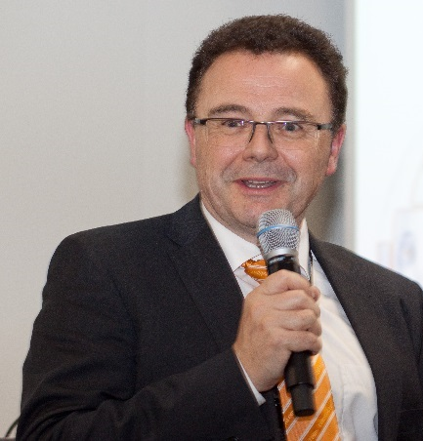
Caption: "We give our customers a clear positive outlook for the future while also ensuring absolute investment protection for existing systems."
Eugen Bollinger, Vice President Sales at TDM Systems.

Image 2:
Caption: "For Industrie 4.0., TDM/TLM must be usable around the world, scalable, and performant extremely well."
Achim Müller, Vice President Technology.

Image 3:
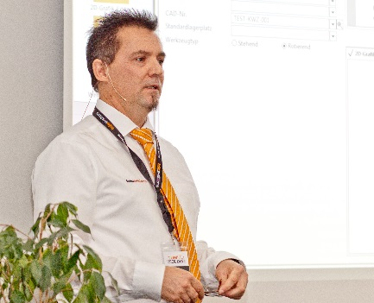
Caption: "We have separated the technical data from the application and thus enable the system to be further developed without changing the system."
Stefan Schmid, Project Manager at TDM Systems.

Image 4:
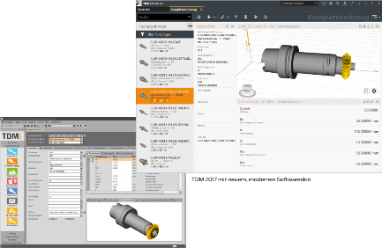
Caption: TDM 2017 and TDM 2017 Global Line with a new, modern user interface.

Images: TDM Systems

Print-quality images are available at:
http://archiv.storyletter.de/download/TDM_PI_next_generation_Images.zip

About TDM Systems
Tübingen-based TDM Systems GmbH has been the leading provider in Tool Data Management for the metal cutting industry for over 25 years. With the tool lifecycle management strategy, TDM Systems is focusing specifically on process optimization through optimal tool planning and provisioning. Creating and editing tool data and graphics, integrating tool expertise and 3D graphics into the CAM engineering and organizing the complete tool cycle at the shop floor level are the three core competencies of TDM Systems and the pillars of the TLM strategy. As a center of expertise within the Sandvik Group, TDM Systems draws on the experience of various tool manufacturers when developing its software products.

www.tdmsystems.com

