TDM Systems goes Industrie 4.0:
Tool Lifecycle Management brings it all together

Around 100 TDM users discussed the future of Tool Data Management at the TDM User Day in Karlsruhe

Tübingen, December 7, 2015 – TDM Global Line and Industrie 4.0 were primary topics of this year's TDM User Day end of November at the Karlsruhe Castle in Germany. Users and software experts from TDM Systems also discussed the many advantages of networking on the shopfloor level. During a workshop, users were able to experience the new software features live in practice.

Three topics of the information and communication technology will significantly influence digital production in the future, according to TDM Systems’ CEO, Peter Schneck: Cloud-based services, the Internet of Things, and the collection and analysis of large data volume. Software will no longer be delivered as a product, "but instead as a service".
The presentation by Thomas Mücke, Senior Business Solution Consultant at TDM Systems, and Michael Grethler, PDM/PLM Director at SolidLine AG, illustrated what is hidden behind the Industrie 4.0-thinking in production. Klemens Haas, a Research Employee at the Institute for Information Management in Engineering at KIT, showed in a live demonstration of how this might look in practice from the design through production of a product. The Collaboration Lab was founded by Prof. Dr.-Ing. Dr. h. C. Jivka Ovtcharova at her Institute over a year ago by several companies, including TDM Systems, and the KIT. Thomas Mücke: "We are there to promote networking with presetting devices, robots, RFID technology, and reverse engineering for digital continuity in the engineering area."

TDM and Global Line Grow Together
In early November, TDM Systems released version 4.8. Eugen Bollinger, VP of Sales & Marketing at TDM Systems: "The innovations affect primarily the TDM Base Module for multi-tools, the graphical 3D tool assembling, as well as the data import from the Machining Cloud and the Tool Crib Module, which now has a WLAN-capable barcode scanner for mobility."
Dr.-Ing. Dipl.-Gwl. Magnus Enßle, Head NC Service and Tool Management of Airbus Helicopters reported from his practical experience. He pointed out the value of "clean tool management for a highly flexible and responsive shopfloor". His company is increasingly working together with external NC-service providers, even more important is the data in TDM: "In the future, we will need to define the tool standard for our partners; accordingly, data administration in TDM is of considerable importance." For Dr. Enßle, networking of Tool Management plays an increasingly important role: "It ensures us a competitive shopfloor in Donauwörth."
"30 to 50 percent savings potential with the new modular toolbox solutions," promises Olaf Sprich, Board Member of the Swiss company Brütsch/Rüegger Werkzeuge AG. Removing a tool with it takes only 15 to 20 seconds; the system ensures full transparency and orders tools by itself upon request. The Toolbox-Software from TDM that has been recently developed for this can be easily integrated into TLM solutions, says Sprich.
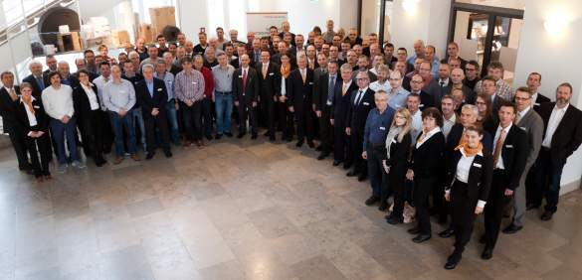
Caption: The future of Tool Data Management 4.0 attracted over 100 specialists at the Karlsruhe Castle in Germany for the TDM User Day 2015.

Image: TDM Systems/M. Pyper

Print-quality images are available at:
http://archiv.storyletter.de/download/TDM_UserDay_2015_Image.zip

About TDM Systems
For over 25 years, TDM Systems GmbH, Tübingen has been the leading provider of Tool Data Management in the area of machining. Using the Tool Lifecycle Management strategy, TDM Systems focuses specifically on process optimization through optimal tool planning and provisioning. Creating and editing tool data and graphics, integrating tool experience and 3D graphics into the CAM engineering, as well as organizing the complete tool cycle at the shopfloor level are the three core competencies of TDM Systems and the pillars of the TLM strategy. As a competence center within the Sandvik Group, TDM Systems draws on the experience of various tool manufacturers when developing its software products.

www.tdmsystems.com

