Know-how on demand
With a new Virtual Academy, TDM Systems is increasingly focusing on the transfer of knowledge

Tübingen – February 23, 2017 – TDM Systems GmbH, the Tübingen, Germany-based Tool Data Management software specialist, has always supported its users with training programs to ensure the best use of its TDM solutions. During training courses in Tübingen, users can educate themselves in direct contact with TDM experts. For customers with a software service and software update contract, TDM Systems has now launched a Virtual Academy – a central point of contact for knowledge building and transfer around Tool Data Management.

"It is important to us that our customers and users are able to take full advantage of their TDM solutions," said Uwe Damberg, Manager of Service & Projects at TDM Systems. For example, after the first training session, which includes the installation of the application, the Tübingen-based Tool Lifecycle Management (TLM) experts continue to accompany their customers by offering a comprehensive range of training courses. The training courses in Tübingen, as well as regular webinars, are available and offered to all users.
TDM Systems is now offering the TDM Virtual Academy (TDMVA) to customers with a software service and software update contract. In video courses, tutorials and webinar recordings, registered users can acquire new knowledge about TLM and their software application and refresh skills already learned.
The centerpiece of the Virtual Academy is the personalized dashboard. Here, at a glance, users can view which courses and lessons they have already visited. In addition, they receive learning proposals that are tailored to their individual learning progress.
"In order to motivate the TDMVA participants and make learning more fun, there are quizzes for many courses and lessons," reports Patrick Kaupp, who supervises the Virtual Academy at TDM. "This allows users to test their learning progress in an entertaining way." As a reward, the user receives points and badges which are displayed on the dashboard.
The official start of the TDM Virtual Academy is January, 2017. Users will then be able to find video courses and webinars in German and English for their training. The offer will not be static, but will be supplemented with new content on a continuous basis.
Click here to register
TDM Systems customers can register for the Virtual Academy at the newly designed TDM customer portal on the website.
Dates for on-site training and webinars can be found on the website at:
https://www.tdmsystems.com/en/consulting/training-in-tuebingen/https://www.tdmsystems.com/en/consulting/webinars/
Image:

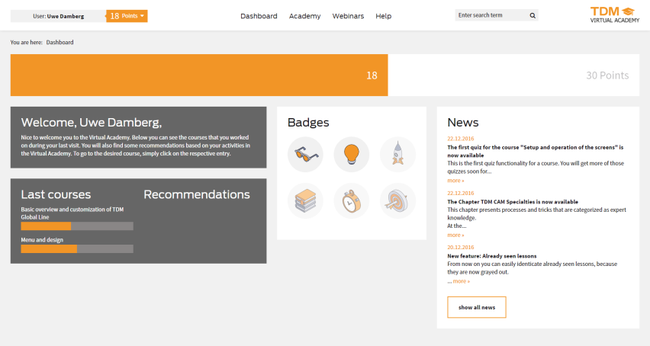
Image 1:
The centerpiece of the Virtual Academy is the personalized dashboard. Here, at a glance, users can view which courses and lessons they have already visited.

Print-quality images are available at:
http://archiv.storyletter.de/download/

About TDM Systems
Tübingen-based TDM Systems GmbH has been the leading provider in Tool Data Management for the metal cutting industry for over 25 years. With the tool lifecycle management strategy, TDM Systems is focusing specifically on process optimization through optimal tool planning and provisioning. Creating and editing tool data and graphics, integrating tool expertise and 3D graphics into the CAM engineering and organizing the complete tool cycle at the shop floor level are the three core competencies of TDM Systems and the pillars of the TLM strategy. As a center of expertise within the Sandvik Group, TDM Systems draws on the experience of various tool manufacturers when developing its software products.

www.tdmsystems.com

