Press release

Increase your profitability efficiency with TDM
With the ROI Calculator, TDM Systems introduces a new tool to increase profitability

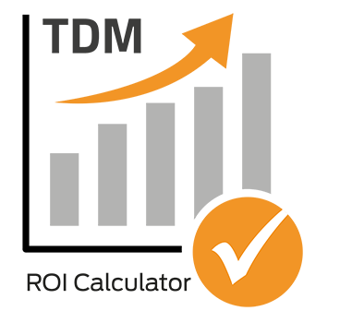
Caption: The TDM ROI Calculator makes TDM investments more transparent.

Tübingen, Germany, June 7th 2018 – Rethinking and cleverly interpreting tool management: Today, TDM Systems is making the TDM ROI Calculator available on its website for calculating return on investment – a useful free of charge tool for calculating potential savings resulting from the use of TDM solutions.
Using the ROI Calculator, the savings you might make by using digital tool management with TDM can be reliably estimated in next to no time. The software from the Tübingen-based tool data experts supports, for example, the reduction of tool variety and the targeted use of the best tools. At the same time, tool-related machine downtimes can be easily reduced and hidden crib inventory minimized.
This new transparency enables companies to understand and optimize their processes. "As a result, our users benefit directly from cost reductions and productivity increases," Eugen Bollinger, Vice President Sales at TDM Systems, explains the advantages for users. The Calculator is available on the TDM Systems website and can be accessed by anyone free of charge.
Using the TDM ROI Calculator, you can quickly and easily estimate initial potential savings and display the results directly on-screen. Should you have any questions, the TDM Systems experts would be happy to help you personally.

Agency contact:

Judith Klingler

Telephone +49 (0) 7071 93872 13
j.klingler@storymaker.de

Storymaker GmbH
Derendinger Strasse 50
72072 Tübingen, Germany
http://www.storymaker.de/
Your contact person:

Sandra Schneck

Telephone +49 (0) 7071 9492 1173
sandra.schneck@tdmsystems.com

TDM Systems GmbH
A member of the Sandvik Group
Derendinger Strasse 53
72072 Tübingen, Germany
http://www.tdmsystems.com/
Twitter: https://twitter.com/TDM_Systems

About TDM Systems

TDM Systems GmbH, Tübingen, has been the leading provider of Tool Data Management in the metal cutting industry for more than 25 years. With the Tool Lifecycle Management strategy, TDM Systems is focusing specifically on process optimization through optimal tool planning and provisioning. Creating and editing tool data and graphics, integrating tool know how and 3D graphics into the CAM engineering and organizing the complete tool circulation at the shopfloor level are the three core competencies of TDM Systems and the pillars of the TLM strategy. As a center of expertise within the Sandvik Group, TDM Systems draws on the know how of various tool manufacturers when developing its software products.

www.tdmsystems.com

