Press release

Solutions from TDM Systems minimize costs

At IMTS 2018, TDM Systems will showcase Tool Data Management solutions for the digital transformation

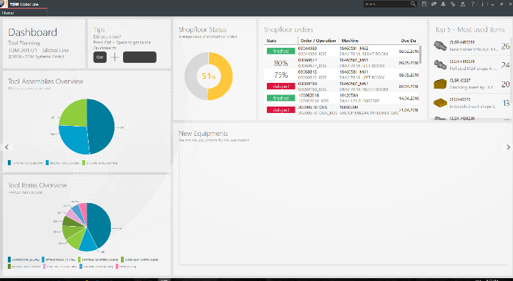
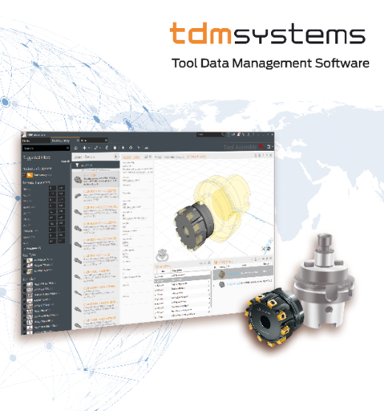

The dashboard in TDM Global Line – the most important tool data at a glance
Image: TDM Systems

Tübingen – July 30, 2018 – Customers of tool data specialist TDM Systems have been proving for 25 years that: The use of tool information at all decision-making and functional levels increases the agility and efficiency of a company. At IMTS 2018 from September 10 to 15 in Chicago, the Tübingen-based company will show metalworking businesses how they can use TDM's latest software modules in a smart factory to record and manage production resources in their entirety. In addition to TDM 2018, TDM Systems will also showcase several cloud-based tool management solutions.
"Getting started with digitization strategy is worth it," promises Peter Schneck, Managing Director of TDM Systems. He believes that companies can save at least 15% of the total cost of ownership through the comprehensive gathering and use of data.
TDM Systems will present the latest version, TDM 2018, with numerous new functions and interfaces just in time for the International Manufacturing Technology Show, IMTS 2018. Data import, data handling and graphics editing have been further optimized. This will benefit users as they will save much more time thanks to the increased level of automation.
TDM Systems is further developing TDM Global Line 2018 so that it will be ready in time for IMTS. As part of this line, the TDM Shopfloor Manager and TDM Machine Process Control (MPC) modules will ensure much more transparency at the manufacturing level. Every user can utilize these modules to arrange their own scope of tasks on a day-to-day basis with our apps, for example.
According to Schneck, the 3D tool assembly is the highlight of TDM Global Line 2018 presented at IMTS. This function "saves users a great deal of time." At its booth, TDM Systems will illustrate how simple it is to build the tools in 3D. TDM Systems will also demonstrate how this solution can be used to manage the tool crib efficiently. Tool data expert Schneck mentions that the TDMcheck process, which checks data and processes in the TDM application and provides suggestions for improvement, will make work much simpler.
TDM Cloud Line for the entry-level segment
TDM Systems is adding TDM Cloud Line to its product range to make Tool Data Management worthwhile for small companies, too. At IMTS, the Tübingen-based company will present the TDM Cloud Line "JobShop" and TDM Cloud Line "Tooling" solutions. These entry-level solutions enable companies such as contract manufacturers to optimize their plans and the use of their tools. The work plan makes it clear which processes are performed to produce the tools and which tools and fixtures are processed. This gradually builds up an expertise database for customers.
Schneck states that users can "get started" with both solutions "straight away; all they need is a computer and a web browser."
The Managing Director promises that an update to TDM 2018 or TDM Global Line 2018 is easy to perform at any time. This is because these solutions use the same technology so that all versions are further developed in parallel.

During IMTS, TDM Systems will showcase its solutions both at its own booth and together with partners:
- TDM Systems East Building, Level 3, booth 133264
- Omega TMM West Building, Level 3, booth 431900
- Allting East Building, Level 2, booth 121539

Images for download:
http://archiv.storyletter.de/download/TDM_AMB_IMTS_2018.zip

Agency contact:

Judith Klingler

Telephone +49 (0) 7071 93872 13
j.klingler@storymaker.de

Storymaker GmbH
Derendinger Strasse 50
72072 Tübingen, Germany
http://www.storymaker.de/
Your contact person:

Sandra Schneck

Telephone +49 (0) 7071 9492 1173
sandra.schneck@tdmsystems.com

TDM Systems GmbH
A member of the Sandvik Group
Derendinger Strasse 53
72072 Tübingen, Germany
http://www.tdmsystems.com/
Twitter: https://twitter.com/TDM_Systems

About TDM Systems

TDM Systems GmbH, Tübingen, has been the leading provider of Tool Data Management in the metal cutting industry for more than 25 years. With the Tool Lifecycle Management strategy, TDM Systems is focusing specifically on process optimization through optimal tool planning and provisioning. Creating and editing tool data and graphics, integrating tool expertise and 3D graphics into the CAM engineering, and organizing the complete tool circulation at the shopfloor level are the three core competencies of TDM Systems and the pillars of the TLM strategy. As a center of expertise within the Sandvik Group, TDM Systems draws on the expertise of various tool manufacturers when developing its software products.

www.tdmsystems.com

