Press release

TDM Shopfloor Manager: The workflow is the guidline
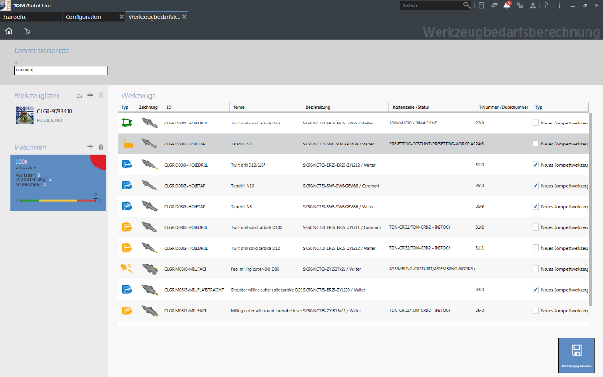
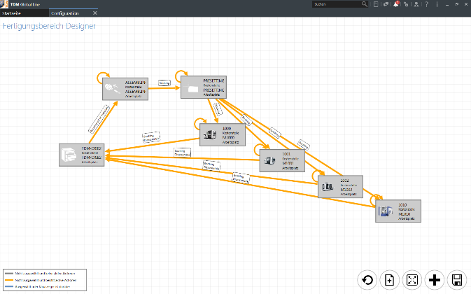
Caption: The TDM Shopfloor Manager provides clear information about where the tools are used and what their condition is.
Image: TDM Systems

Caption: The TDM Shopfloor Manager follows the process. Sensible processes are already created by default in the software.
Image: TDM Systems

Tübingen, 5th September 2018 – User-friendliness, digital networking and process optimization: TDM Systems, a software developer in the field of tool management, continuously expands shopfloor management under TDM Global Line.
"With the TDM Shopfloor Manager in TDM Global Line, the customer can use a configurator to individually compile all workflows." For Volker Schwegler, Senior Consultant and Product Manager at TDM Systems, this means that the days when a shopfloor had to adapt to rigid software are now in the past. Consistently modular in design, the shopfloor management adapts to all conceivable circumstances in order planning, configuration and the workflow for cribs, assembly, presetting, machine and secondary cribs. The tool list forms the basis for every requirements calculation – "no matter whether we are dealing with orders, individual workpieces or NC programs, in the end, everything is broken down into tool lists".

The user situation is decisive
During development, TDM Systems is always oriented towards each user's respective situation. Every person involved in a process should be able to view the precise information they require for their specific task. Additional guidline: The real tool circulation, which arises from the configuration in question. A crib, a presetting area and a machine are typical, where tasks are assigned to each of these areas. Typical – but not universal. Schwegler: "Many companies combine assembly and presetting together in one tool room, for example. The two areas can be combined in this case to form a cost center – the "tool room" – and all actions can be combined into a single screen."
Everything freely configurable
Thanks to a modular design, the software is freely configurable, without any need to adapt the programming. Schwegler: "It therefore follows the process – it is no longer the other way round." This flexibility also drastically reduces the individual adjustment effort. At least 80 per cent of customer requests can be covered as standard. However, too much flexibility could lead to faults if processes are compiled in the wrong sequence. This prevents an integrated plausibility check, which only permits sensible sequences. "We will soon also only be able to preselect processes that are also sensible, promises Schwegler.
The TDM Shopfloor Manager from TDM is fully compatible with the stock management of the TDM Tool Crib Module Global Line. This means that even tool assemblies in secondary cribs and those near machines can be managed. You can therefore always know precisely where the tool assemblies are and what condition they are in. Disassembling, reassembling and presetting are no longer strictly necessary, saving significant time and costs. "We therefore have the best overview in the tool circulation for each user," Volker Schwegler states with conviction.

Print-quality graphics are available at:
http://archiv.storyletter.de/download/TDM_PI_Shopfloor_Manager.zip

Agency contact:

Judith Klingler

Telephone +49 (0) 7071 93872 13
j.klingler@storymaker.de

Storymaker GmbH
Derendinger Strasse 50
72072 Tübingen, Germany
http://www.storymaker.de/
Your contact partner:

Sandra Schneck

Telephone +49 (0) 7071 9492 1173
sandra.schneck@tdmsystems.com

TDM Systems GmbH
A member of the Sandvik Group
Derendinger Strasse 53
72072 Tübingen, Germany
http://www.tdmsystems.com/
Twitter: https://twitter.com/TDM_Systems

About TDM Systems

TDM Systems GmbH, Tübingen, has been the leading provider of Tool Data Management in the metal cutting industry for more than 25 years. With the Tool Lifecycle Management strategy, TDM Systems is focusing specifically on process optimization through optimal tool planning and provisioning. Creating and editing tool data and graphics, integrating tool know how and 3D graphics into the CAM engineering and organizing the complete tool circulation at the shopfloor level are the three core competencies of TDM Systems and the pillars of the TLM strategy. As a center of expertise within the Sandvik Group, TDM Systems draws on the know how of various tool manufacturers when developing its software products.

www.tdmsystems.com

