Press release

Change of management at TDM Systems
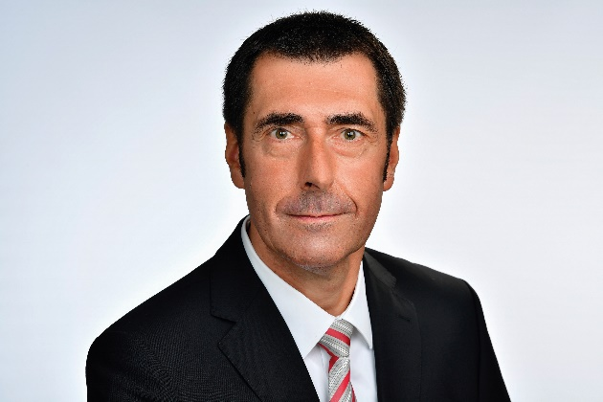
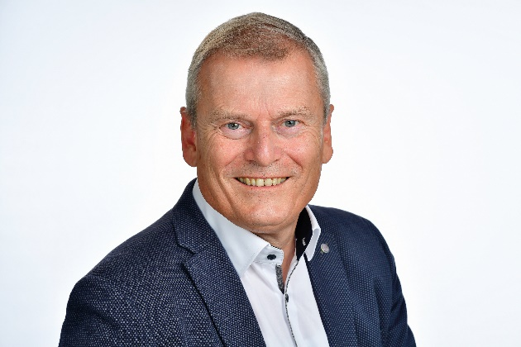
From October 1st 2018, Dietmar Bohn will be the new Managing Director of TDM Systems.
Image: TDM Systems

Peter Schneck, Managing Director of TDM Systems for the past five years, is retiring.
Image: TDM Systems

Tübingen, October 1st 2018 – Dietmar Bohn, most recently in a position of leadership at SAP SE, will take over the management of TDM Systems GmbH. He is following in the footsteps of Peter Schneck, who is retiring after five years at the head of the tool data specialist company.
Dietmar Bohn is joining TDM Systems from SAP SE. He spent 14 years in various positions of leadership at the Walldorf/Germany-based software company, most recently as Vice President of Industry Solution Management. The electrical engineer began his professional career in 1990 as a systems developer of machinery control systems at Heidelberger Druckmaschinen AG, where he quickly took on managerial roles, rising to become Director of Global Processes.
Dietmar Bohn's goal is to take an active approach in shaping digital transformation and manufacturing in the future – and he is in just the right place for this at TDM Systems: "TDM Systems was, and is, a pioneer in digitalization. It brings together in-depth manufacturing and software expertise, and as a result its solutions and products impress across the market. It is precisely this combination of areas of expertise that I am bringing to the company too." Together with the team at TDM, he will focus on developing solutions for successfully supporting manufacturing companies around the world in digital transformation.
Bohn is taking over the position of Managing Director from Peter Schneck. Schneck worked as the CIO at Walter AG for several decades and took over the management of TDM Systems – part of the Sweden-based Sandvik Group – five years ago. He is now retiring – which was his plan from the start – to continue working toward a digital future in his private life and in a voluntary capacity.

Print-quality images are available via the following link:
http://archiv.storyletter.de/download/TDM_PI_GF-Wechsel.zip

Your contact partner:

Sandra Schneck

Telephone +49 (0) 7071 9492 1173
sandra.schneck@tdmsystems.com

TDM Systems GmbH
A member of the Sandvik Group
Derendinger Strasse 53
72072 Tübingen, Germany
http://www.tdmsystems.com/

Agency contact:

Judith Klingler

Telephone +49 (0) 7071 93872 13
j.klingler@storymaker.de

Storymaker GmbH
Derendinger Strasse 50
72072 Tübingen, Germany
http://www.storymaker.de/

About TDM Systems

TDM Systems GmbH, Tübingen, has been the leading provider of Tool Data Management in the metal cutting industry for more than 25 years. With the Tool Lifecycle Management strategy, TDM Systems is focusing specifically on process optimization through optimal tool planning and provisioning. Creating and editing tool data and graphics, integrating tool expertise and 3D graphics into the CAM engineering, and organizing the complete tool circulation at the shopfloor level are the three core competencies of TDM Systems and the pillars of the TLM strategy. As a member of the Sandvik Group, TDM Systems draws on the expertise of various tool manufacturers when developing its software products.

www.tdmsystems.com

