**Press Release**

Strategic partnership:

Mastercam distributes TDM solutions in India

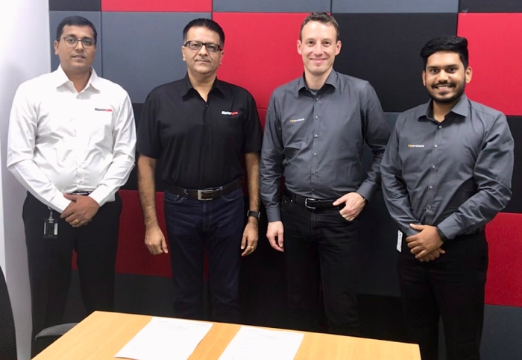

*Daniel Raravi-Mktg Director-Mastercam APAC, Vineeth Seth-MD-Mastercam APAC, Robert Auer-Global sales partner-TDM, Viraj Shinde-TDM Product manager-Sandvik India*

**Pune, India, January 15, 2019 –** Customers of tool data specialist TDM Systems have been proving for 25 years that: The use of tool information at all decision-making and functional levels increases the agility and efficiency of a company. As a leading provider of solutions for digital manufacturing in the metal cutting industry, the wholly-owned subsidiary of the SANDVIK Group attaches particular importance to manufacturer independence and partnerships. Since December of last year, Mastercam India has also been part of the TDM Systems partner network. The CAD/CAM expert supports distribution of the TDM software in India.

The demand and need for Tool Data Management, in mature Industry 4.0 applications is currently very large in one of the most important growth markets of the world - India. Commenting on the strategic partnership, "We have been working very closely with the Sandvik Coromant group – both at the HQ level and regionally in India. We are pleased to partner with another subsidiary of Sandvik - TDM Systems, and through our collective offering, provide customers with a well-rounded solution that involves the tooling system," said Vineet Seth, Managing Director – South Asia & Middle East, for Mastercam APAC.

**About TDM Systems**

TDM Systems GmbH, Tübingen, has been the leading provider of Tool Data Management in the metal cutting industry for more than 25 years. With the Tool Lifecycle Management strategy, TDM Systems is focusing specifically on process optimization through optimal tool planning and provisioning. Creating and editing tool data and graphics, integrating tool expertise and 3D graphics into the CAM engineering, and organizing the complete tool circulation at the shopfloor level are the three core competencies of TDM Systems and the pillars of the TLM strategy. As a member of the Sandvik Group, TDM Systems draws on the expertise of various tool manufacturers when developing its software products.

[www.tdmsystems.com](http://www.tdmsystems.com)

**[](https://www.youtube.com/channel/UCaHqITJyeDNaYMce65pGfeA) [](https://www.linkedin.com/company/tdm-systems) [](https://twitter.com/TDM_Systems)**

**About CNC Software, Inc.**

Founded in 1983, CNC Software, Inc. is a privately held company headquartered in Tolland, Connecticut. The company develops Mastercam, a suite of CAD/CAM software created to reduce production time and expense with efficient machining strategies and advanced toolpath technologies. Mastercam is the world’s #1 CAM software, with more than 250,000 installations in industries such as moldmaking, automotive, medical, aerospace, consumer products, education, and prototyping. It is distributed through an international channel of authorized Mastercam Resellers in 75 countries, providing localized sales, training, and support for 2- through 5-axis routing, milling, and turning; 2- and 4-axis wire EDM; 2D and 3D design; surface and solid modeling; artistic relief cutting; and Swiss machining.

Mastercam APAC is responsible for Mastercam business in the South Asia and Middle East regions and support over 3500 customers through direct offices as well as a network of over 30 resellers in the region.

[**www.mastercamapac.com**](http://www.mastercamapac.com)

