Press release

Up-to-date tool data from the cloud
At the EMO 2019 trade show, TDM Systems will present its innovative Tool Data Management system, TDM Global Line 2019 – a solution for optimum tool planning and provision that is accessible from anywhere in the world
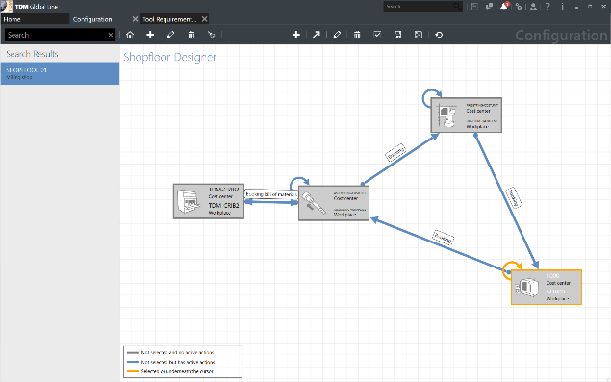
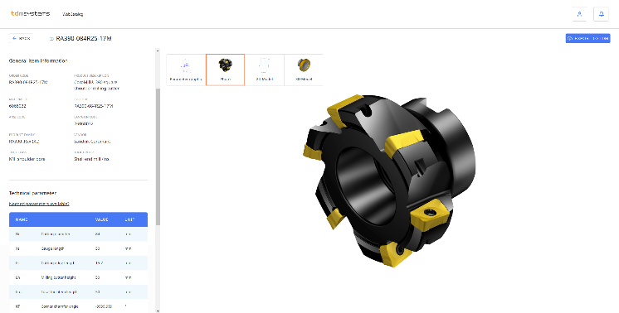
TDM Global Line 2019 accelerates machining companies' manufacturing processes. The shopfloor work flow can be individually configured. Picture: TDM Systems

The right tool is only a few clicks away. TDM WebCatalog provides up-to-date and verified tool data from the cloud.
Picture: TDM Systems

Tübingen, 17. July 2019 – TDM Global Line 2019 manages tools according to items, tool assemblies and tool lists. The major advantage of this system is that its central database is available to users at all company sites. The central installation and configuration of the solution reduces IT costs and promotes synergies across multiple locations. The new online tool "TDM WebCatalog" makes Tool Data Management significantly easier in many other aspects as well: At any time, users can quickly access tool data that is always up to date and verified, and can integrate this into their TDM solution with a simple mouse click.
At the EMO 2019 in Hanover, TDM Systems GmbH will present its TDM WebCatalog to the public for the first time. The cloud application will be available to customers with TDM Global Line 2019 and TDM 2019 as of August. Using the TDM WebCatalog, users can retrieve the current tool data of leading manufacturers and retailers such as ARNO, Hoffman Tools, Sandvik Coromant and Walter. Other interesting solutions are currently being prepared. The cloud catalogs can be used to set up completely new tool databases within the company, as well as update and supplement existing ones.
Simple handling and time savings
"The highlight of the TDM WebCatalog is that the data and graphics of the selected tool can be sent directly to TDM," explains Eugen Bollinger, Head of Sales at TDM Systems. "The user does not have to create the tool again separately; rather, it is directly assigned to the appropriate class and group structure." The TDM WebCatalog also impresses the users with its flexible text search function. Regardless of whether the user is searching according to order number, supplier, an application or technical parameters, all the data required for further processing is available within a very short time.
Thanks to the TDM WebCatalog, the time-consuming process of creating a tool database is a thing of the past. Particularly during the introduction of TDM, this had been a major hurdle for businesses. "We speed up this process by up to 80 percent," explains Bollinger enthusiastically.
TDM Global Line 2019: Efficient tool management
Those who wish to use the TDM WebCatalog need to register with TDM Systems and also be users of TDM Global Line 2019 or TDM 2019 (or later versions). The interaction of the cloud catalogs with current and future releases will make the Tool Data Management of machining companies of all sizes more efficient than ever before. The central, globally accessible database, the quick integration of current and high-quality tool data and an individually configurable shopfloor work flow – along with many other features – considerably speed up the entire manufacturing process. Additionally, TDM Systems places great emphasis on the fact that TDM is not an isolated solution. Around 20 quality-tested and maintained CAM interfaces ensure seamless communication between manufacturing-relevant systems – an indispensable aspect in the age of Industrie 4.0.

TDM Systems at the EMO 2019, September 16 - 21:
- TDM Systems booth: Hall 9, F24
- DMG MORI booth: Hall 2 at north entrance
- KELCH booth: Hall 4, B61

Print-quality images are available via the following link:
http://archiv.storyletter.de/download/TDM_EMO_2019_WebCatalog_GlobalLine.zip

Your contact partner:

Sandra Schneck

Telephone +49 (0) 7071 9492 1173
sandra.schneck@tdmsystems.com

TDM Systems GmbH
A member of the Sandvik Group
Derendinger Strasse 53
72072 Tübingen, Germany
http://www.tdmsystems.com/

Agency contact:

Judith Klingler

Telephone +49 (0) 7071 93872 13
j.klingler@storymaker.de

Storymaker GmbH
Derendinger Strasse 50
72072 Tübingen, Germany
http://www.storymaker.de/

About TDM Systems

For over 25 years, TDM Systems GmbH, Tübingen has been the leading provider of Tool Data Management in the area of machining. With the tool life-cycle management strategy, TDM Systems is focusing specifically on process optimization through optimal tool planning and provisioning. Creating and editing tool data and graphics, integrating tool know how and 3D graphics into the CAM engineering and organizing the complete tool circulation at the shopfloor level are the three core competencies of TDM Systems and the pillars of the TLM strategy. As a member of the Sandvik Group, TDM Systems draws on the expertise of various tool manufacturers when developing its software products.

www.tdmsystems.com

