Press release

Tool Data Management: good support and advice at all times

TDM Systems and its TDM-Service Center in China
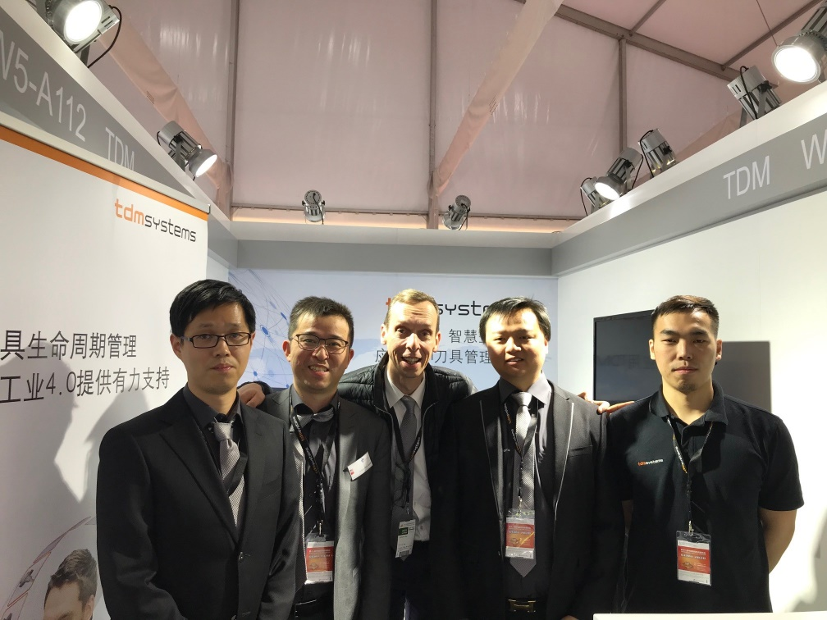

The Tedan team of the Chinese TDM Service Center with Christian Kübel from TDM Systems, Germany: Glori Yan, Jeffery Zhao, Christian Kübel, Haipeng Du, Allen Wang (left to right)

Shanghai / Tübingen, Germany, December xx, 2019 – TDM Systems, the leading company for tool data management, is pushing ahead with its internationalization. Together with its partner company Tedan Information and Technology（Shanghai） Co., Ltd., TDM Systems is announcing the TDM service center in China. Based in Shanghai, the team supports many Chinese users with their TDM solutions.
Like TDM Systems, Tedan Information and Technology focuses on solutions that help metal-cutting companies digitize their manufacturing processes. The Chinese and German companies have already been partners for six years; together they have opened the Chinese market for tool data management software and won customers who are already receiving comprehensive support from Tedan today. As an official TDM Service Center, the Tedan team can now provide even better support to users in the Greater China Region (GCR).
"Our employees are real TDM experts. They know the solutions down to the last detail and support the users in fully exploiting the potential of their TDM applications and thus their entire production", says Jeffery Zhao, Managing Director at Tedan.
"With Tedan, we have a very reliable partner in China who knows TDM inside out and shares our commitment to mature solutions for digital manufacturing," emphasizes Christian Kübel, Director of Sales Asia Pacific at TDM Systems. "In order to open up new markets, it is absolutely essential that the transfer of know-how to the customer takes place directly on site and in the local language. This is now guaranteed in China."
Your contact partner:

Sandra Schneck

Telephone +49.7071.9492-1173
sandra.schneck@tdmsystems.com

TDM Systems GmbH
A Member of the Sandvik Group
Derendinger Strasse 53
72072 Tübingen, Germany
http://www.tdmsystems.com/

About TDM Systems

TDM Systems GmbH, Tübingen, has been the leading provider of Tool Data Management in the metal cutting industry for more than 25 years. With the Tool Lifecycle Management strategy, TDM Systems is focusing specifically on process optimization through optimal tool planning and provisioning. Creating and editing tool data and graphics, integrating tool expertise and 3D graphics into the CAM engineering, and organizing the complete tool circulation at the shopfloor level are the three core competencies of TDM Systems and the pillars of the TLM strategy. As a member of the Sandvik Group, TDM Systems draws on the expertise of various tool manufacturers when developing its software products.

www.tdmsystems.com

