Press release

TDM Systems wins new partner for Scandinavia

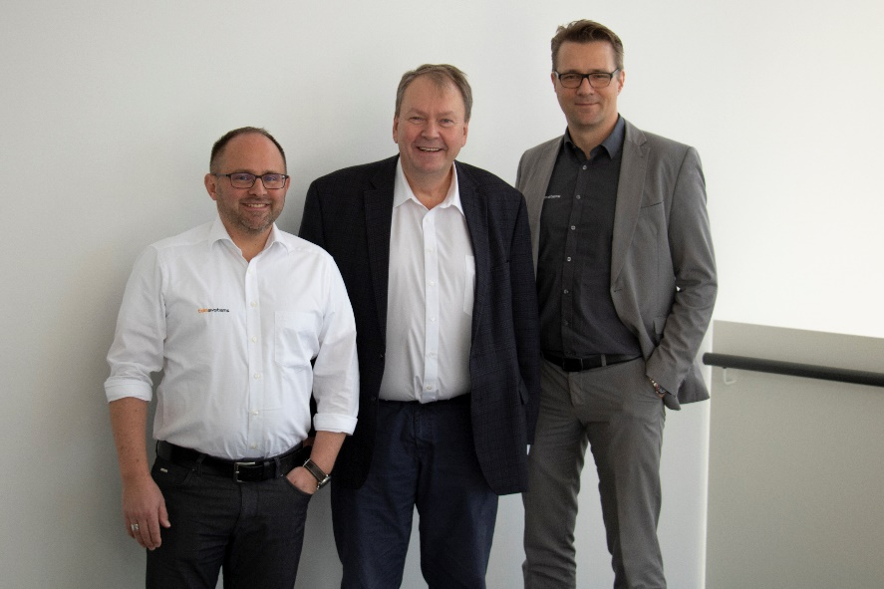

New sales team for Scandinavia: Götz Schrade, Sales TDM Systems, and Seppo Lehtonen, CEO Finlatec; accompanied by Robert Buschmann, Director of Sales Central Europe TDM Systems (left to right)

Tübingen, February 11, 2020 – From now on, automation expert Seppo Lehtonen, Managing Director of Finlatec, will support TDM Systems in selling Tool Data Management solutions in Scandinavia.
"Software solutions for tool data management are not yet widely used in the Nordic countries," says Seppo Lehtonen, referring to his many years of experience in the manufacturing sector. "This is really surprising, as the Scandinavians have a great affinity for new technologies and digital issues." In addition, due to their high-wage location, companies must increasingly automate and digitalize their production in order to remain competitive. Lehtonen: "TDM Systems' tool management solutions are the most advanced on the market. And they are perfectly suited to help companies optimize their production".
Götz Schrade, sales representative of TDM Systems, underlines: "We see great potential in the Scandinavian market with large manufacturing companies. Seppo Lehtonen, like TDM Systems, has been active in the industry for more than 25 years. Together we will be able to convince companies of the great benefits of Tool Data Management."

Your contact partner:

Sandra Schneck

Telefon +49.7071.9492-1173
sandra.schneck@tdmsystems.com

TDM Systems GmbH
A Member of the Sandvik Group
Derendinger Strasse 53
72072 Tübingen, Germany
http://www.tdmsystems.com/

Agency contact:

Judith Klingler

Telefon +49.7071.93872-13
j.klingler@storymaker.de

Storymaker GmbH
Derendinger Strasse 50
72072 Tübingen, Germany
http://www.storymaker.de/

About TDM Systems

TDM Systems GmbH, Tübingen, has been the leading provider of Tool Data Management in the metal cutting industry for more than 25 years. With the Tool Lifecycle Management strategy, TDM Systems is focusing specifically on process optimization through optimal tool planning and provisioning. Creating and editing tool data and graphics, integrating tool expertise and 3D graphics into the CAM engineering, and organizing the complete tool circulation at the shopfloor level are the three core competencies of TDM Systems and the pillars of the TLM strategy. As a member of the Sandvik Group, TDM Systems draws on the expertise of various tool manufacturers when developing its software products.

www.tdmsystems.com

