Press release

TDM tool management: The 2020 release is driving digitalization further forward
New and further developments are increasing the efficiency and agility of machining companies

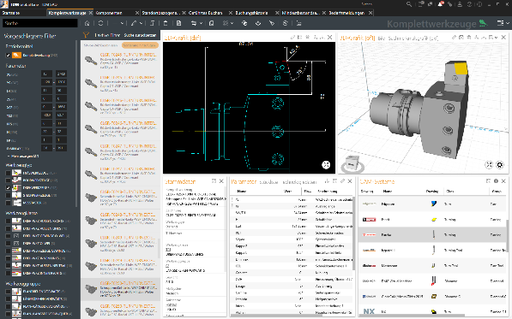
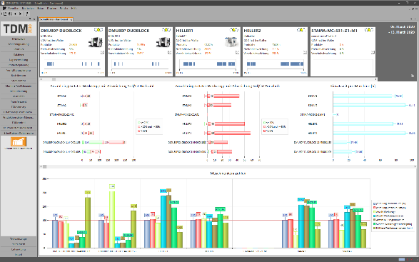
With the Global Line 2020 release, users can keep an eye on all tool data. Image: TDM Systems
In the new TDM release, cutting data is recorded, evaluated and saved directly from the machine. Image: TDM Systems
Tübingen, July 7, 2020 – TDM Systems, the digitalization specialist for the machining industry, is introducing the latest version of their TDM and TDM Global Line solutions into the market on July 7. The two main 2020 releases of the digital tool management software offer numerous further developments but also offer new modules that users can use to reduce their tooling costs and increase their efficiency.

"The challenges facing machining companies are enormous: In order to overcome the current crisis, they have to reduce their costs quickly and substantially," stresses Dietmar Bohn, Managing Director of TDM Systems. For him, the key to being more cost-effective, quicker and more agile in manufacturing is digitalization. According to Bohn, machining companies can now take a further step towards networking and data usage thanks to the latest generation of the TDM and TDM Global Line tool management software.
"With these latest releases, we are underlining our commitment to working as a full-service provider offering solutions for the company-wide, digitalized management of tools and equipment which increase the efficiency and competitiveness of machining companies," adds Bohn.
One highlight here is that, with the new TDM Global Line 2020 release, users achieve greater transparency regarding their tooling costs and key figures. This is possible because each user can now individually configure their TDM Global Line dashboard. The relevant reports can then either be displayed in the dashboard, printed out or simply transferred to Excel. Since real-time data is always evaluated – for example, the value of the used and new tools or the number of items and tool assemblies created – the controlling is valid. "Users are therefore able to keep an eye on the figures that they need, which makes them significantly more decisive in how they do business," states the Managing Director.
In addition to numerous improvements and further developments in the TDM Shopfloor Manager and the Tool Crib apps, the latest release also provides new modules in TDM Global Line:
- TDM NC-Program Manager Global Line: Thanks to the transparent management of NC documents, this powerful tool guarantees a continuous production process. Furthermore, the existing application expertise is retained by the company.
- TDM Purchase Requisition Module Global Line: This application can be used to easily manage tool requirements and forward them to the ERP system. This also makes the tool orders more transparent, which helps the company to provide all of the required tools at the right time and in the right quantities.
- TDM 3D Solid Editor Global Line: This editor can be used to easily modify and adapt 3D models. Companies therefore achieve significant time-savings when creating 3D models. The graphics quality is also increased and the 3D models can be put to even better use for simulation analyses.
In addition to TDM Global Line, the Tübingen-based tool data specialists also further developed their core solution, TDM.

TDM 2020: New module closes the gaps between planning and production
With the new release, the TDM Feeds & Speeds Manager, among other things, is available to users. In conjunction with the Comara Box, the actual applied cutting data is recorded, compressed and evaluated directly from the machine. By comparing the planned cutting values that are defined in the NC program with the actual applied cutting values in the machine, in future, it will be possible to specify reliable cutting values as early as the planning phase. This reduces the risk of machine downtimes caused by incorrect feeds & speeds and reduces the tooling costs thanks to more targeted tool selection and procurement. Furthermore, using this module leads to comprehensive time-savings in planning and production. The use of verified data in the NC programming also improves the product quality. Yet another advantage of using the TDM Feeds & Speeds Manager: The expertise from production is saved centrally; in other words, even if employees leave the company, the knowledge is retained.
With the latest release, many of the improvements are also the result of an intensive exchange with the customers and/or analyses of the TDM applications in the companies. In doing so, some applications for data and graphics maintenance have been optimized based on practical experience, meaning that the full utilization potential for existing data and graphics can be tapped. With the 2020 release, the completeness check of CAM-specific tool data has also become more transparent. And yet another customer demand has been met: The automated calculation of collision data. This is something that is particularly advantageous for CATIA and NX users.
It is therefore clear to the TDM Systems Managing Director: "Since we are continuously aligning our development strategy to the needs of our customers and the future trends of the manufacturing industries, with our digital tool management, we offer a practical and innovative solution with a high value contribution."

Print-quality graphics are available at:
http://archiv.storyletter.de/download/TDM_GL_TDM_Release2020_Images_english.zip

Your contact partner:

Sandra Müller (formerly Schneck)

Telephone +49 (0) 7071 9492 1173
sandra.schneck@tdmsystems.com

TDM Systems GmbH
A member of the Sandvik Group
Derendinger Strasse 53
72072 Tübingen, Germany
http://tdmsystems.com/

Agency contact:

Mara Ebinger

Telephone +49 (0) 7071 9387 2159
m.ebinger@storymaker.de

Storymaker GmbH
Derendinger Strasse 50
72072 Tübingen, Germany
http://www.storymaker.de/

About TDM Systems
For over 25 years, TDM Systems GmbH, Tübingen has been the leading provider of Tool Data Management in the area of machining. With the Tool Lifecycle Management strategy, TDM Systems is focusing specifically on process optimization through optimal tool planning and provisioning. Creating and editing tool data and graphics, integrating tool expertise and 3D graphics into the CAM engineering, and organizing the complete tool circulation at the shop-floor level are the three core competencies of TDM Systems and the pillars of the TLM strategy. As a member of the Sandvik Group, TDM Systems draws on the expertise of various tool manufacturers when developing its software products.

www.tdmsystems.com

