Press release

TDM Systems joins forces with ToolsUnited to offer more than 900,000 new tool data records
The new interface represents a huge expansion of data available to TDM users. What's more, it means tool data can now be found for virtually every machining operation.
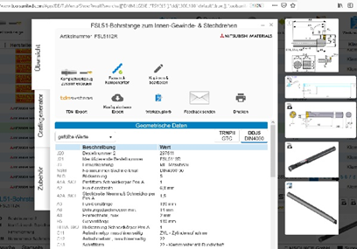
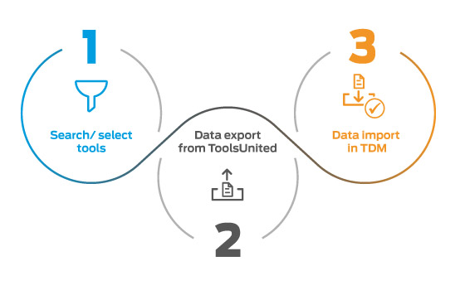
The new interface to ToolsUnited pushes digitization further. Image: TDM Systems
Over 900,000 data records of more than 40 manufacturers are available in the ToolsUnited data pool. Image: TDM Systems

Tübingen, November 05, 2020 – TDM Systems makes further advances in digitalization. The Tübingen-based experts in digitalized tool management have now implemented an interface to ToolsUnited, which is available as an optional add-on for all TDM users operating TDM 2018 version or higher and to all hybrid users of TDM Global Line and TDM.

TDM users can now access over 900,000 data records of more than 40 manufacturers from the ToolsUnited data pool. As an official partner, TDM Systems enables its users to purchase a ToolsUnited Flat package directly from them. "This partnership represents a huge increase in the data available to our users. We are now able to offer tool data for virtually every machining operation," says Uwe Sauer, Head of Strategic Projects at TDM Systems.
TDM's own automated data creation solutions, such as the TDM WebCatalog or the TDM Data and Graphic Generator, help minimize the effort required for data creation and maintenance. The partnership also now allows users to use the complete ToolsUnited data pool via CIMSOURCE. The extensive range of data covering a wide variety of machining tools also supports the digitalization process. This brings with it many advantages: The expansion of the data records available optimizes processes and the wide array of tool data increases the efficiency of machining operations. Direct access to tool data from over 40 manufacturers creates a high degree of flexibility and makes data management ultra-efficient.
The benefits are not only limited to the production process, but also make the data handling process simple and intuitive: Tools are selected using the ToolsUnited filter function. The data records are placed in the ToolsUnited shopping cart and exported to TDM as a package. These records are then automatically checked in TDM and, if necessary, can be edited before they are saved in the master data.
The partnership between TDM Systems and CIMSOURCE therefore represents an important step for machining companies in terms of the expansion and widespread use of tool data for efficient digital production.

Print-quality images are available via the following link:
http://archiv.storyletter.de/download/xxxxxxx http://archiv.storyletter.de/download/TDM_ToolsUnited_Images.zip

Your contact person:

Sandra Müller (formerly Schneck)

Telephone +49 (0) 7071 9492 1173
sandra.schneck@tdmsystems.com

TDM Systems GmbH
A member of the Sandvik Group
Derendinger Strasse 53
72072 Tübingen, Germany
https://www.tdmsystems.com/en/

Agency contact:

Mara Ebinger

Telephone +49 (0) 7071 9387 2159
m.ebinger@storymaker.de

Storymaker GmbH
Derendinger Strasse 50
72072 Tübingen, Germany
https://www.storymaker.de/

About TDM Systems
For over 25 years, TDM Systems GmbH, Tübingen has been the leading provider of Tool Data Management in the area of machining. With the Tool Lifecycle Management strategy, TDM Systems is focusing specifically on process optimization through optimal tool planning and provisioning. Creating and editing tool data and graphics, integrating tool expertise and 3D graphics into the CAM engineering, and organizing the complete tool circulation at the shop-floor level are the three core competencies of TDM Systems and the pillars of the TLM strategy. As a member of the Sandvik Group, TDM Systems draws on the expertise of various tool manufacturers when developing its software products.

www.tdmsystems.com

