Press release

New: Cloud-based entry-level solution for tool management

TDM Systems will launch TDM Cloud Essentials in April 2021 – developed especially for small companies
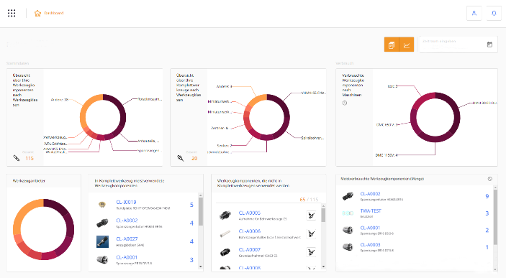
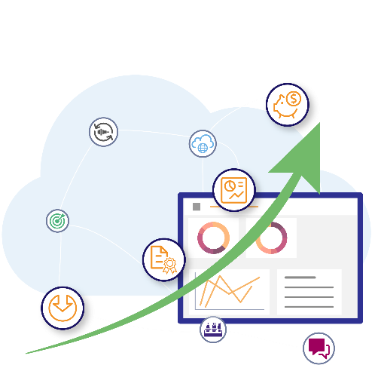

Everything at a glance with the TDM Cloud Essentials dashboard.
Image: TDM Systems
The entry-level solution in cloud-based tool management for small machining companies.
Image: TDM Systems

Tübingen, 14th April 2021 – Simply register and get started right away! That is now possible for companies with the entry-level solution from TDM Systems that do not require an IT installation. TDM Cloud Essentials is a cloud-based tool management system developed especially for small companies that have shied away from digital tool management until now.
"Our solution is simple and does not require project management or an IT installation. Companies simply need to register and can get started straight away," explains Daniel Friedrich. He is responsible for the development and implementation of the cloud-based entry-level solution to tool management at TDM Systems.
It offers enormous potential for optimization – particularly for companies with small to medium-sized production facilities. With this cloud-based software they can regain an overview of their tools and further advance digitalization on their shopfloor.
These days, even small companies – particularly those looking to grow – are feeling the disadvantages of inefficient tool management, such as having no overview, growing tooling costs, escalating crib inventories, long setup times and quality issues.
But the obstacles to entering the world of digital tool management have previously been too high to overcome for these companies. According to Friedrich, it is particularly the IT resources and time for implementing a software and training employees that small companies are lacking. Many companies are also shying away from the initial investment cost.
TDM Cloud Essentials will change this. "For the first time, these companies can start managing their tools quickly and simply."
The fast and uncomplicated use is just one of the benefits offered. The pricing structure is also tailored to the needs of small-scale production. TDM Cloud Essentials is offered as SaaS (Software as a Service). Users operate the software with a time-based subscription. The monthly fees cover all IT services such as updates and data backup. This also means there is no initial investment. If the company and therefore the requirements grow, new subscriptions can be added easily. As a result, companies can remain agile and competitive while they are growing.
And there is another aspect that Friedrich thinks users will love: The effort required for importing relevant data to the system is minimal. On the one hand, this is because the focus lies on only recording essential data with a direct benefit for tool management. On the other hand, TDM Systems also offers convenient options for data import. This also includes the free of charge access to the TDM WebCatalog with more than 250,000 data records from leading manufacturers. In this way, users are also creating the foundation for data export into a CAM system at a later stage.
The TDM Cloud Essentials entry-level solutions clears the way for smaller companies, creates transparency and bundles the know-how of employees. That is because the daily challenges of tool management, particularly in small companies, were analyzed in great detail before developing the solution. The new tool management solution was then implemented with these insights and the experience of TDM solutions that have proven themselves over the course of many years. That is why Friedrich is sure: "With TDM Cloud Essentials, companies will regain an overview of their tools that will make them more agile and competitive".
Further information at: https://www.tdm-cloud.com/

Print-quality images are available via the following link:
http://archiv.storyletter.de/download/Images_TDM_Cloud_Essentials.zip

Your contact:

Sandra Müller (formerly Schneck)

Telephone +49 (0) 7071 9492 1173
sandra.mueller@tdmsystems.com

TDM Systems GmbH
A member of the Sandvik Group
Derendinger Strasse 53
72072 Tübingen, Germany
http://tdmsystems.com/

Agency contact:

Mara Ebinger

Telephone +49 (0) 7071 9387 2159
m.ebinger@storymaker.de

Storymaker GmbH
Derendinger Strasse 50
72072 Tübingen, Germany
http://www.storymaker.de/

About TDM Systems
For over 30 years, TDM Systems GmbH, Tübingen has been the leading provider of tool management solutions in the area of machining. TDM Systems focuses specifically on process optimization through optimal tool planning and provisioning. Creating and editing tool data and graphics, integrating tool expertise and 3D graphics into the CAM engineering, and organizing the complete tool circulation at the shopfloor level are the three core competencies of TDM Systems. TDM Systems also offers a cloud-based entry-level solution for tool management especially for small companies with TDM Cloud Essentials. As a member of the Sandvik Group, TDM Systems draws on the expertise of various tool manufacturers when developing its software products.

www.tdmsystems.com

