Press release

TDM Systems is advancing digitalization on the shopfloor
The main release 2022 from TDM Global Line and TDM is expanding data management and integration capacity – expansion in shopfloor management
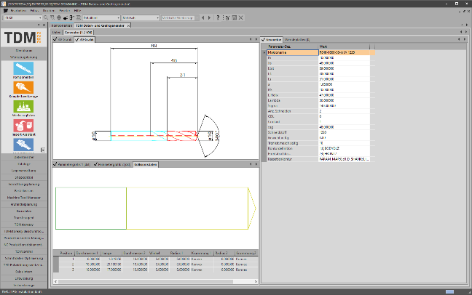
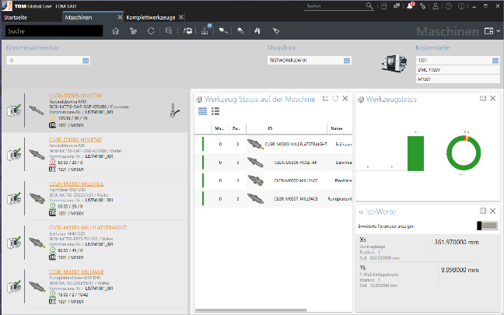
The TDM Global Line release 2022 drives digitalization forward in the area of shopfloor management and machine communication, among others. Image: TDM Systems
An innovation of the TDM release2022: The Collision Data Generator creates the collision data at the same time as the other data is created.
Image: TDM Systems

Tübingen, 16th September 2021 – The new main release 2022 from TDM Global Line and TDM is now available to users. In both software lines from TDM Systems, the leading provider of digital tool management solutions, numerous customer demands have again been implemented. In particular, the data management and integration capacity of both software solutions, which can be used in combination, have been expanded.

"With our current main release, we are offering manufacturing companies an even better solution for their digital strategy," states Jean-Paul Seuren, VP Global Sales & Marketing at TDM Systems. And he points out that, with the new main release from TDM Global Line, the strengths of both software lines have been further expanded. All in all, numerous new features have been implemented in both systems, including many customer demands. One growing trend is the further development of shopfloor management and machine communication in order to achieve greater transparency with regard to the remaining tool life and tool supply to the machine. For Jean-Paul Seuren, VP Global Sales & Marketing at TDM Systems, "machine connections are a 'logical step' in the further development of tool management towards a closed data flow.

The integration capacity of TDM Global Line is now significantly increased by the expanded ERP interface in TDM Global Line; the full scope of the SAP interface is also now available. A focus in the current further development of TDM Global Line 2022 is the improved system application thanks to the practical administration and the expanded rights management, which allows for consistent implementation of application profiles, right down to the function level. The Next-ID feature is also new and it allows for the automatic assignment of individual IDs.

However, also with TDM 2022, thanks to data management innovations and new and improved features, the main release ensures easier, direct handling. In order to directly merge quality data from various sources, the TDM Important Assistant has been expanded, for example. The automatic dimensioning of 2D graphics and the TDM Collision Data Generator are also new: The new module for the TDM Data and Graphics Generators saves an enormous amount of time for CAM users of the CATIA and Siemens NX systems because it creates collision data at the same time as the other data is created.

In the TDM Feeds & Speeds Manager, data retransfer is the key topic. The module that was established on the market with the release 2020 has been further developed. The TDM Feeds & Speeds Manager allows for the compaction and analysis of real driven cutting data from the machine control system. To make better use of the data, the driven tools are now assigned to an NC order and can then be comprehensively analyzed. This means that savings potentials can be identified, and planning data can be improved.

TDM Systems has now changed its rhythm when naming the annual software releases. The current release 2022 directly follows the release2020. The next release 2023 is expected to be available at the end of 2022.

Print-quality images are available via the following link:
http://archiv.storyletter.de/download/TDM_PI_Release2022_Images.zip

Your contact person:

Sandra Müller (formerly Schneck)

Telephone +49 (0) 7071 9492 1173
sandra.mueller@tdmsystems.com

TDM Systems GmbH
A member of the Sandvik Group
Derendinger Strasse 53
72072 Tübingen, Germanyhttp://tdmsystems.com/

Agency contact:

Mara Ebinger

Telephone +49 (0) 7071 9387 2159
m.ebinger@storymaker.de

Storymaker GmbH
Derendinger Strasse 50
72072 Tübingen, Germany
http://www.storymaker.de/

About TDM Systems
For over 25 years, TDM Systems GmbH, Tübingen has been the leading provider of tool management solutions in the area of machining. TDM Systems focuses specifically on process optimization through optimal tool planning and provisioning. Creating and editing tool data and graphics, integrating tool expertise and 3D graphics into the CAM engineering, and organizing the complete tool circulation at the shopfloor level are the three core competencies of TDM Systems. TDM Systems also offers a cloud-based entry-level solution for tool management especially for small companies with TDM Cloud Essentials. As a member of the Sandvik Group, TDM Systems draws on the expertise of various tool manufacturers when developing its software products.

www.tdmsystems.com

