Press release

In focus: The potential of tool data
At the CIMT, TDM Systems is presenting digital solutions for efficient tool management

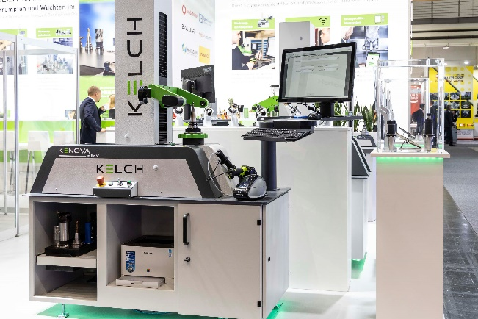

At the CIMT, TDM Systems is presenting their solutions for digital tool management at three partner booths. Image: TDM Systems

Tübingen, April 5, 2021 – TDM Systems is presenting their solutions for digital tool management at the China International Machine Tool Show (CIMT) 2021, one of the world's largest and most influential trade shows for machine tools. The German software company is presenting the advantages of the digitalization of tool data in a practical way at three partner booths.

"With TDM Global Line, users get the most out of their tool data," explains Christian Kuebel, Sales Director APAC at TDM Systems. The comprehensive solution which, in Kuebel's opinion, "from a global point of view, is the best system for digital tool management", is being presented at the CIMT, which takes place from April 12 to 17, 2021 in Beijing.
The world's leading software manufacturer for managing tool data is exhibiting their digitalization solution, which companies can use to optimize production processes, reduce their costs and increase their agility, at three booths. A decision that Kuebel welcomes: "By showing the potential of our solutions at the booths of our technology, service and sales partners, we are close to our customers and can specifically address their problems."
TDM Global Line and TDM 2020
The TDM Systems service partner Tedan Information and Technology Co., Ltd., which is located in Shanghai, China, is exhibiting their solutions at booth E2-B402 and, in conjunction with this, is also demonstrating the advantages of intelligent tool management. Both TDM and TDM Global Line will be presented. Solutions which, according to Kuebel, "will strengthen the users' competitiveness in the long term." This is because, in addition to reducing costs, increasing productivity and improving quality, they also increase the agility across the entire tool cycle.
Presented: Data cycle in logistics and planning
At booth W1 A014 for the American tool specialist Omega, TDM Systems demonstrates how TDM Global Line, including the connection to Omega presetting devices, allows for the complete data cycle in logistics and planning. Omega is an American manufacturer and distributor of presetting devices. At its booth, the company is not only presenting a variety of their own products. They will also provide visitors with a live demonstration of how, with TDM Systems solutions, they can use their tool data to optimize their logistics and planning. "The entire data cycle is presented," explains Kuebel. The visitors will recognize precisely how they can reduce their tool-related machine downtimes and also reduce their tooling costs.
Presented: Interface to tool presetting devices
At booth E1-B001, TDM Systems is presenting along with KELCH, a manufacturer of tool presetting devices. The German company KELCH, a wholly owned subsidiary of Harbin Measuring & Cutting Tool Group Co., Ltd (HMCT), offers an extremely wide range of vertical tool presetting devices across the world. At booth E1-B001 (HMCT booth), visitors are shown, in particular, how effortlessly and securely the TDM Global Line transfers data from and to various KELCH tool presetting devices via an interface. Kuebel is certain that "what our partners are demonstrating will impress visitors. They will immediately appreciate just how much they can increase their competitiveness with TDM solutions."

Print-quality images are available via the following link:
http://archiv.storyletter.de/download/Images_TDMSystems_CIMT_2021.zip

Your contact person:

Sandra Müller (formerly Schneck)

Telephone +49 (0) 7071 9492 1173
sandra.mueller@tdmsystems.com

TDM Systems GmbH
A member of the Sandvik Group
Derendinger Strasse 53
72072 Tübingen, Germany
http://tdmsystems.com/

Agency contact:

Mara Ebinger

Telephone +49 (0) 7071 9387 2159
m.ebinger@storymaker.de

Storymaker GmbH
Derendinger Strasse 50
72072 Tübingen, Germany
http://www.storymaker.de/

About TDM Systems
For over 30 years, TDM Systems GmbH, Tübingen has been the leading provider of tool management solutions in the area of machining. TDM Systems focuses specifically on process optimization through optimal tool planning and provisioning. Creating and editing tool data and graphics, integrating tool expertise and 3D graphics into the CAM engineering, and organizing the complete tool circulation at the shopfloor level are the three core competencies of TDM Systems. TDM Systems also offers a cloud-based entry-level solution for tool management especially for small companies with TDM Cloud Essentials. As a member of the Sandvik Group, TDM Systems draws on the expertise of various tool manufacturers when developing its software products.

www.tdmsystems.com

