Press release

2023 release: New modules optimize process
The new 2023 release for TDM ClassiX and TDM Global Line will be available from December 12th, 2022
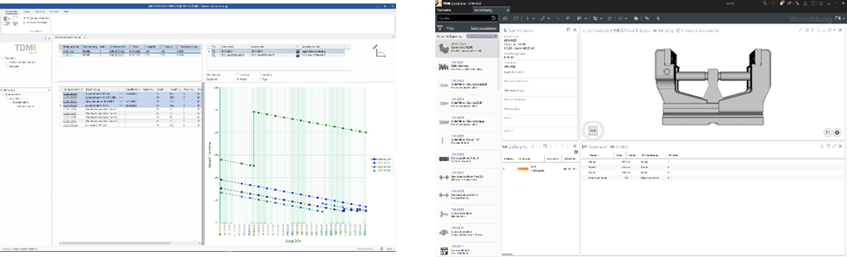
The Fixture Management Module improves the planning reliability of TDM Global Line users. Image: TDM Systems
With the TDM Range Calculator, tool requirements are more predictable and can be calculated with greater precision. Image: TDM Systems

Tübingen, December 12, 2022 – TDM Systems makes the latest releases of TDM ClassiX 2023 and TDM Global Line 2023 available to its customers from December 12th, 2023. Both lines of software from the market leader for tool management present users with extensive new features. The software improvements are focused on simplifying handling and, first and foremost, optimizing planning processes.
"Downtimes are a thing of the past. Because with our new TDM Range Calculator module, tool requirements are now even more predictable and can be calculated with greater precision," explains Timo Kanz, Head of Product & Technology at TDM Systems. The TDM Range Calculator is one of the latest innovations from the TDM ClassiX software line. The module provides a realistic calculation of the tool requirements for pending production orders. This calculation is based on such data as the number of possible regrinding processes, the tool life quantity, and the minimum stock level. This gives users an earlier indication of whether there are sufficient tools – or how many machining days and workpieces they will last – and when they need to reorder to ensure minimum stock levels at all times.
What's more, the software has undergone a comprehensive facelift to adapt it to the modern design standards of MS Office. Kanz explains that the result is a completely new, clean user interface design that allows users to "work intuitively and efficiently."
The new release contains more than 260 modifications in many modules and application scenarios. Kanz believes these wide-ranging expansions and improvements prove that TDM Systems is committed to "developing our solutions systematically and always in the customers' interests."
The highlights of the 2023 release of TDM Global Line
For TDM Global Line users, the new release offers more efficient processes in tool assembly. This is because besides supporting RFID data carriers, which ensure seamless data exchange, the new release now also facilitates crib entries via barcode scanner, multiple selection of tools and, in turn, faster entries for a setup order, and more besides.
Another new feature for users of TDM Global Line is the Fixture Management Module. The module, which TDM ClassiX customers have long since used and valued, is now also available for TDM Global Line customers. Since fixtures are an integral element of production and setup planning, this will "improve the planning reliability and, with it, the utilization of the machines," stresses Kanz.
In addition to this, new filter options in the Global Line Shopfloor Manager ensure more overall user friendliness within tool management, so that, for instance, tools with critical tool life can be detected sooner. New status options, such as new entry, locked or phase-out part also increase transparency within tool use. Kanz is confident “that this new release fulfills our bold claim of offering 100 percent tool management and, in turn, further strengthening the transparency, planning reliability and capacity of machining companies."

Timo Kanz, Head of Product & Technology at TDM Systems. Image: TDM Systems

Print-quality images are available via the following link:
http://archiv.storyletter.de/download/TDM_Release2023_Images.zip

Your contact:

Daniela Steinhart

Telephone +49 (0) 7071 9492 760
daniela.steinhart@tdmsystems.com

TDM Systems GmbH
A member of the Sandvik Group
Derendinger Strasse 53
72072 Tübingen, Germany
www.tdmsystems.com

Agency contact:

Mara Ebinger

Telephone +49 (0) 7071 9387 2159
m.ebinger@storymaker.de

Storymaker GmbH
Derendinger Strasse 50
72072 Tübingen, Germany
www.storymaker.de/en

About TDM Systems
For over 30 years, TDM Systems GmbH, Tübingen has been the leading provider of tool management solutions in the area of machining. TDM Systems focuses specifically on process optimization through optimal tool planning and provisioning. Creating and editing tool data and graphics, integrating tool expertise and 3D graphics into the CAM engineering, and organizing the complete tool circulation at the shopfloor level are the three core competencies of TDM Systems. TDM Systems also offers a cloud-based entry-level solution for tool management especially for small companies with TDM Cloud Essentials. As a member of the Sandvik Group, TDM Systems draws on the expertise of various tool manufacturers when developing its software products.
www.tdmsystems.com

