Press release

More expertise when it comes to the machine: TDM Systems is growing and joining forces with Comara, a company that specializes in production optimization
TDM Systems and Comara are joining forces for a portfolio expansion regarding machine data analysis.

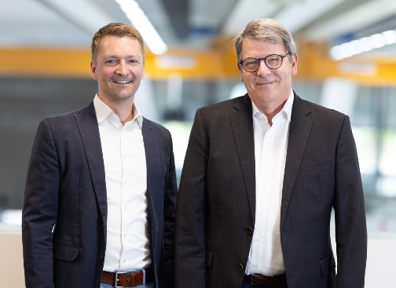

Jean-Paul Seuren, Managing Director at TDM Systems GmbH and Holger Langhans, Managing Director at Comara GmbH, are pleased with the merger of their companies.

Tübingen, August 2023 – TDM Systems, leading provider of software solutions for tool management, is expanding its expertise and product portfolio by adding the area of expertise of machine connection thanks to the merger with Comara GmbH.
"We want to be the No. 1 digital partner for our customers, and that's why the merger of TDM Systems and Comara is an important step towards machine data expertise. We now offer our customers completely new options for evaluating OEE key figures and machine data," emphasizes Jean-Paul Seuren, Managing Director at TDM Systems. This is because the product portfolios of both companies complement each other ideally when it comes to the CNC machine: TDM Systems provides innovative solutions that take care of data management and the physical organization of tools right through to the machine. Comara GmbH specializes in machine data acquisition and/or the evaluation and analysis of machine data as well as solutions for production optimization. This enables the creation of comprehensive OEE analyses as well as analysis of the current machine condition and also the monitoring of downtimes. A point that, among other things, is also relevant for tool planning.
As of August 1, 2023, TDM Systems is integrating all Comara solutions into its own portfolio and therefore providing the entire data and process chain, from planning through to the machine. By combining their expertise, TDM Systems aims to provide even greater support to customers in meeting the requirements for end-to-end digital manufacturing. Holger Langhans, Managing Director at Comara GmbH, is also looking forward to the future with TDM Systems: "We are very pleased to add our nearly 20 years of expertise in machine data acquisition to TDM Systems' area of expertise at an important point in the machining process. In the future, our joint customers will have ONE central contact for optimizations along the entire machining process."
By integrating Comara solutions and Comara expertise into TDM's portfolio, TDM Systems enables companies to leverage the huge potential of their data from the machine as well, allowing them to manufacture more efficiently.

Print-quality images are available via the following link:
https://archiv.storyletter.de/download/TDM_Comara_Seuren_Langhans.jpg

Your contact:

Sandra Müller

Telephone +49 (0) 7071 9492 1173
sandra.mueller@tdmsystems.com

TDM Systems GmbH
A member of the Sandvik Group
Derendinger Strasse 53
72072 Tübingen, Germany
http://tdmsystems.com/

Agency contact:

Mara Ebinger

Telephone +49 (0) 7071 9387 2159
m.ebinger@storymaker.de

Storymaker GmbH
Derendinger Strasse 50
72072 Tübingen, Germany
http://www.storymaker.de/

About TDM Systems
For 30 years, TDM Systems GmbH, Tübingen has been the leading provider of tool management solutions in the area of machining. TDM Systems focuses specifically on process optimization through optimal tool planning and provisioning. Creating and editing tool data and graphics, integrating tool expertise and 3D graphics into the CAM planning, and organizing the complete tool circulation at the shopfloor level are the three core competencies of TDM Systems. TDM Systems also offers a cloud-based entry-level solution for tool management especially for small companies with TDM Cloud Essentials. As a member of the Sandvik Group, TDM Systems draws on the expertise of various tool manufacturers when developing its software products.

www.tdmsystems.com

